

**DIPARTIMENTO DI INGEGNERIA INFORMATICA, MODELLISTICA, ELETTRONICA E SISTEMISTICA**

Project: "Active Suspension System "

Model based control systems

2022/2023

Professor: Casavola A.

Student: Rustemova A.

**Contents**

1. Introduction
2. System modelling
   1. Mathematical model
   2. State-space representation
   3. Electromechanical actuator
   4. Design of disturbances
3. System analysis
   1. Internal stability
   2. Structural properties
      1. Reachability
      2. Observability
   3. Free response
4. Control strategies
   1. Filter implementation
   2. $H_{∞}$ optimal control
   3. $H_{2}$ optimal control
   4. Multi-objective control
      1. $H_{∞}-α$ stability control
   5. Robust control
      1. $H_{∞}$ robust control
   6. Linear parameter varying systems and gain-scheduling control
   7. State-flow controller
5. Conclusion
6. References
7. **Introduction**

The design and implementation of advanced suspension systems have gained significant attention in the automotive industry due to their potential to enhance ride comfort and vehicle handling. Traditional passive suspension systems, although effective to a certain extent, often struggle to provide optimal ride quality and stability under varying road conditions. To overcome these limitations, active suspension systems have emerged as a promising solution.

Active suspension systems utilize advanced control algorithms, sensors, and actuators to actively adjust the suspension characteristics in real-time. By continuously monitoring the vehicle's motion and road inputs, these systems can adapt the suspension parameters to mitigate the effects of bumps, potholes, and other disturbances. The result is a smoother ride, improved traction, reduced body roll, and enhanced overall vehicle dynamics.

The most frequent method for the study of the suspension performance is the “quarter car model”, by which case is “divided” in four friction components, attached to each wheel. In this case, the quarter-car (the quarter of the car chassis) is the “sprung mass” while the tire with its auxiliary components is the “unsprung mass”. The suspension system consists of an energy dissipating element, which is the damper (or “shock absorber”) and an energy storing element which is the spring.

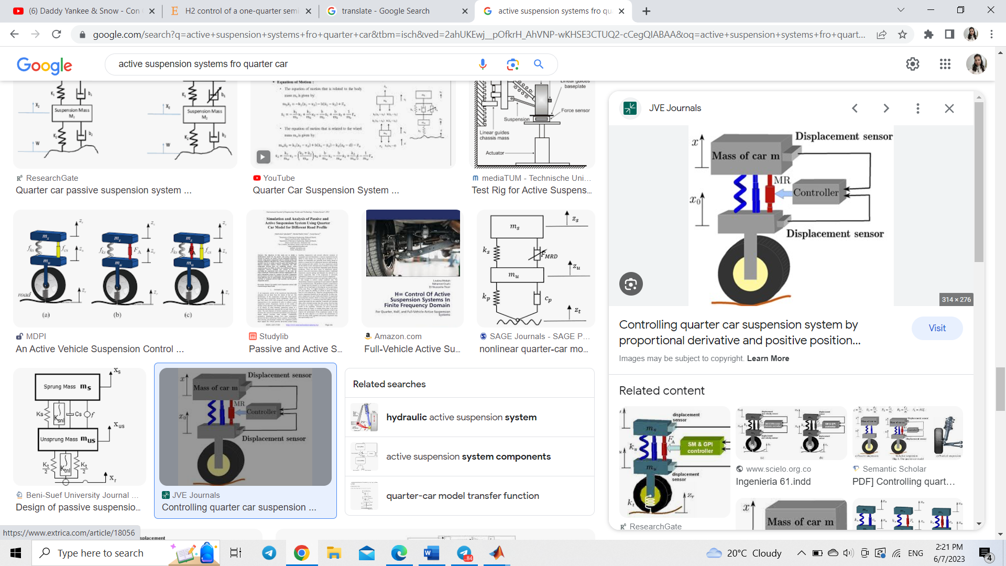

**Fig.1.**Active suspension system

1. **System modelling**
   1. **Mathematical model**

The mass ***ms*** represents the car chassis (body) and the mass ***mu*** represents the wheel assembly. The spring ***ks*** and damper ***cs***represent the passive spring and shock absorber placed between the car body and the wheel assembly. The spring ***ku*** models the compressibility of the pneumatic tire. The variables ***zs***, ***zu***, and ***zr*** are the body travel, wheel travel, and road disturbance, respectively. The force ***f*** applied between the body and wheel assembly is controlled by feedback and represents the active component of the suspension system.

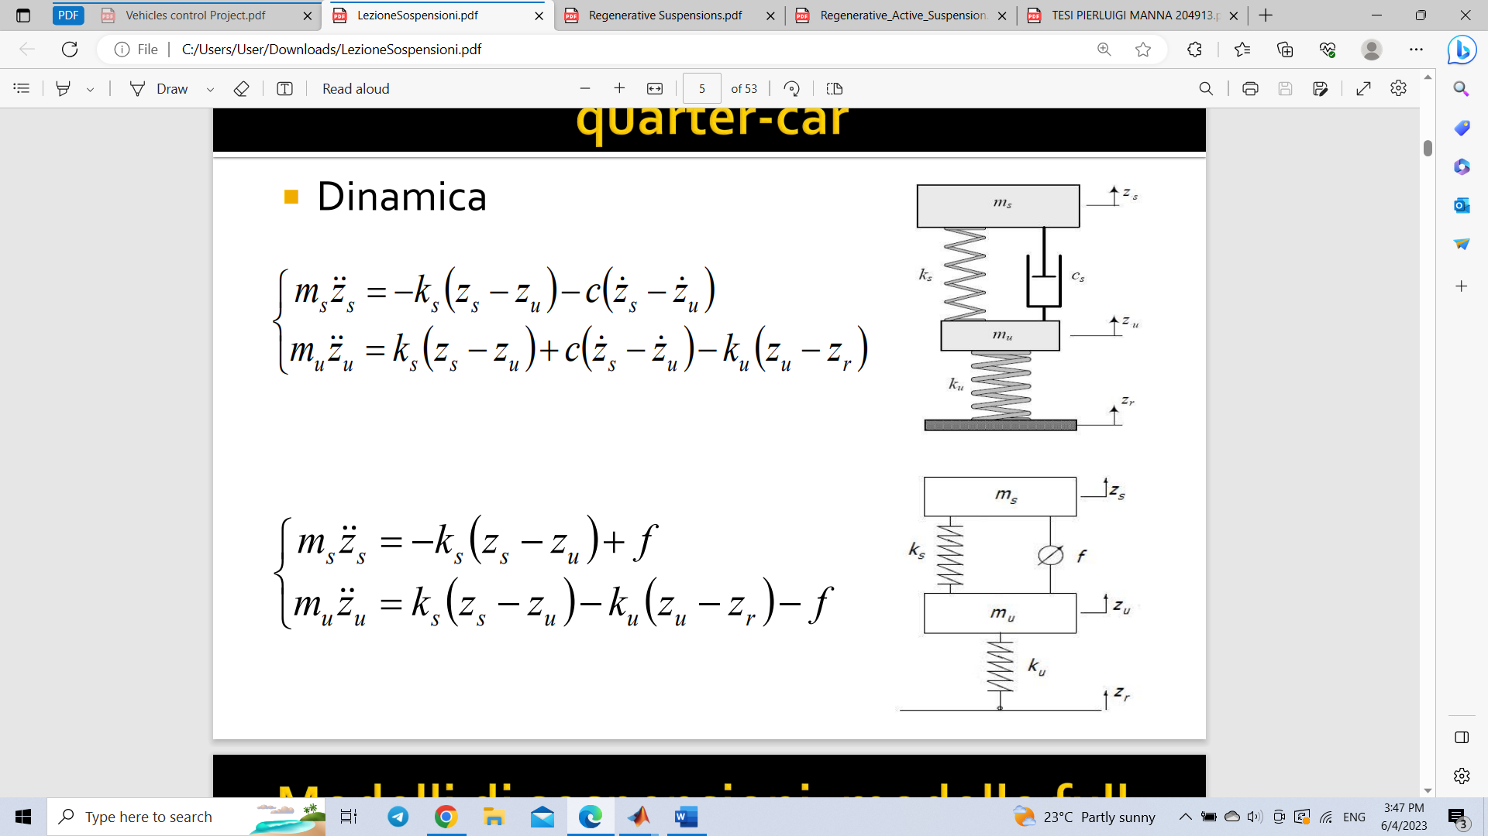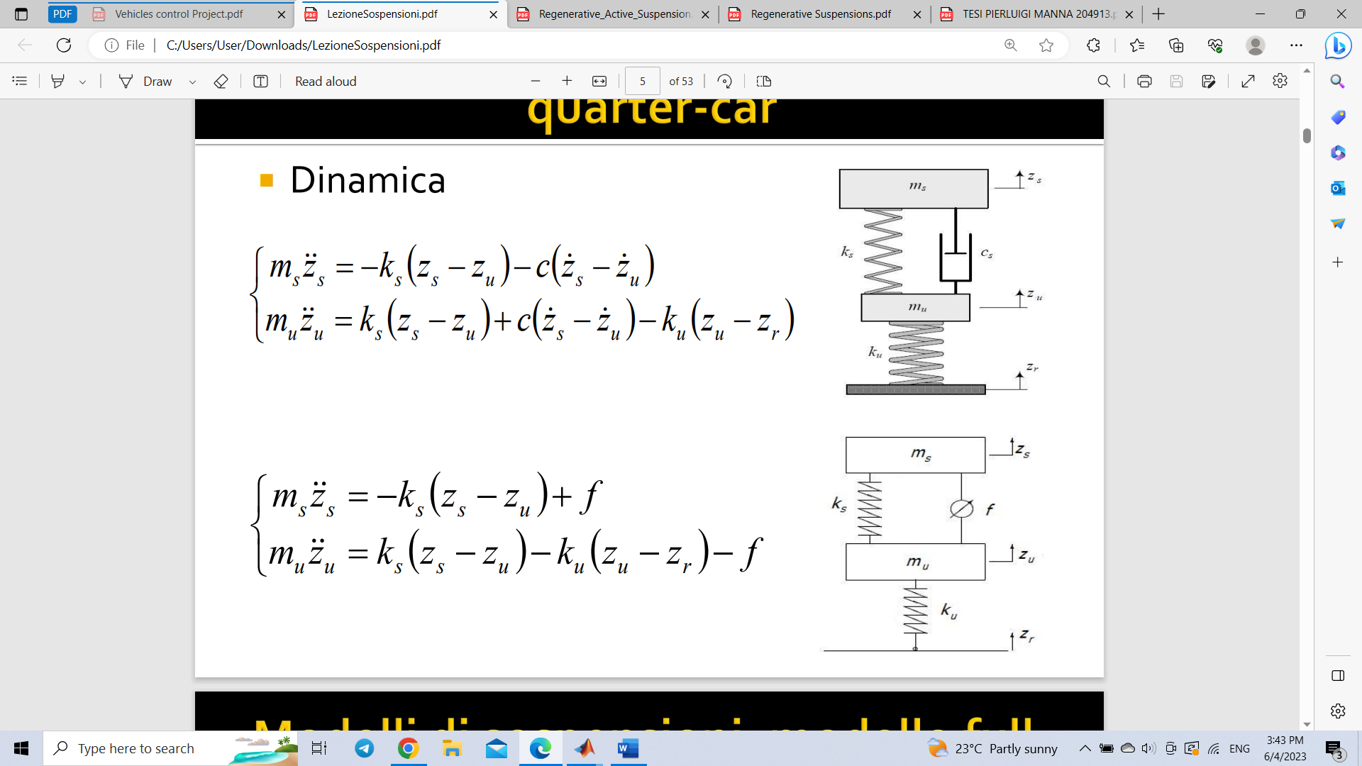

**Fig.2.1.**  Passive Setup (left), Active setup (right)

To derive the equations useful for modeling the system, the second principle of dynamics is used, applied to mass $m_{s}$ and to the mass $m_{u}.$

Dynamics of passive viscous model:

$$m_{s}{\ddot{z}}_{s}=-ks\left(zs-zu\right)-cs\left(\dot{ zs}-\dot{ zu}\right)$$

$$m_{u}{\ddot{z}}_{u}= ks\left(zs-zu\right)+cs\left(\dot{ zs}-\dot{ zu}\right)-ku\left(zu-zr\right)$$

Dynamics of active model:

* 1. **State space representation**

From the abovementioned mathematical equations, we can derive the following state-space representation:

* 1. **Electromechanical actuator**

Linear permanent-magnets actuator. Linear equations, simple model $f=Ki$

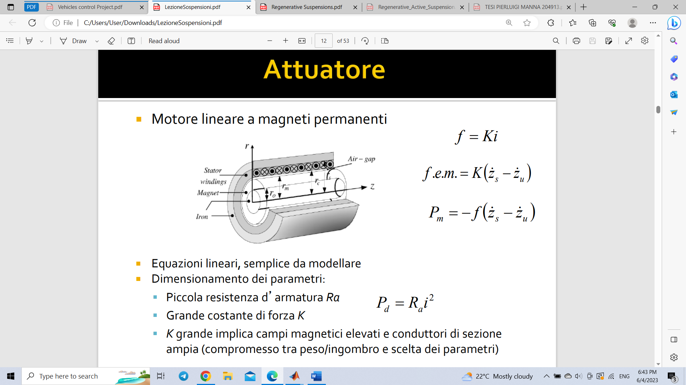

**Fig.2.3 Electromechanical actuator scheme**

**Parameters of the model**

|  |  |  |
| --- | --- | --- |
| Sprung mass | $$m_{s}$$ | 318.5kg |
| Unsprung mass | $$m_{u}$$ | 35.5kg |
| Suspension stiffness | $$k_{s}$$ | 27kN/m |
| Tire stiffness | $$k_{u}$$ | 228kN/m |
| Force constant |  | 938N/m |

* 1. **Disturbances acting on the system. ISO-8608 standard for road roughness**

The main disturbance acting on the system is road roughness. One of the most useful tools to describe the stationary road roughness is the power spectral density (PSD). When a car moves at a constant velocity $v$, the road roughness can be viewed as a stationary process in space domain, and the PSD of the road disturbance input can be expressed by

$$G_{d}\left(n\right)=G(n_{0}){\left(\frac{n}{n_{0}}\right)}^{-2}$$

where, $G_{d}\left(n\right)$ is the road PSD, n is the spatial frequency. The reference spatial frequency $n_{0}$ can be defined by $n_{0}$ = 0.1(cycle /m), $G(n_{0})$ is the road roughness coefficient, which is the value of PSD at the reference spatial frequency $n_{0}$ and represent different grades of road. The main classes into which roads are divided by the ISO 8608 standard are shown in the following table:

|  |  |  |
| --- | --- | --- |
| Type of the road | Description | $$G\left(n_{0}\right)*{10}^{-6}m^{3}$$ |
| A | Very good motorways | $$≤8$$ |
| B | Good principal roads | [8,32] |
| C | Average principal roads | [32,128] |
| D | Poor minor roads | [128,512] |
| E | Very poor | [512,1024] |

It can be seen from the following figure how different class of roads are classified depending roughness.

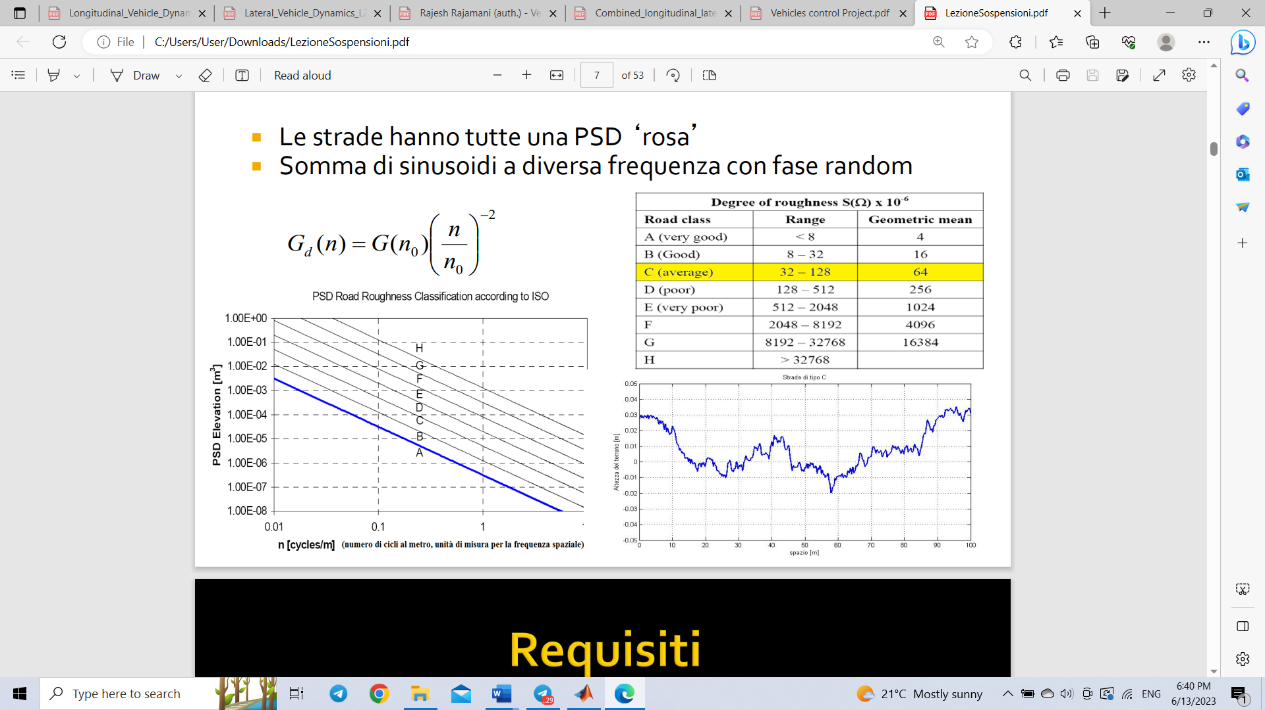

**Fig.2.4.1 PSD road roughness classification**

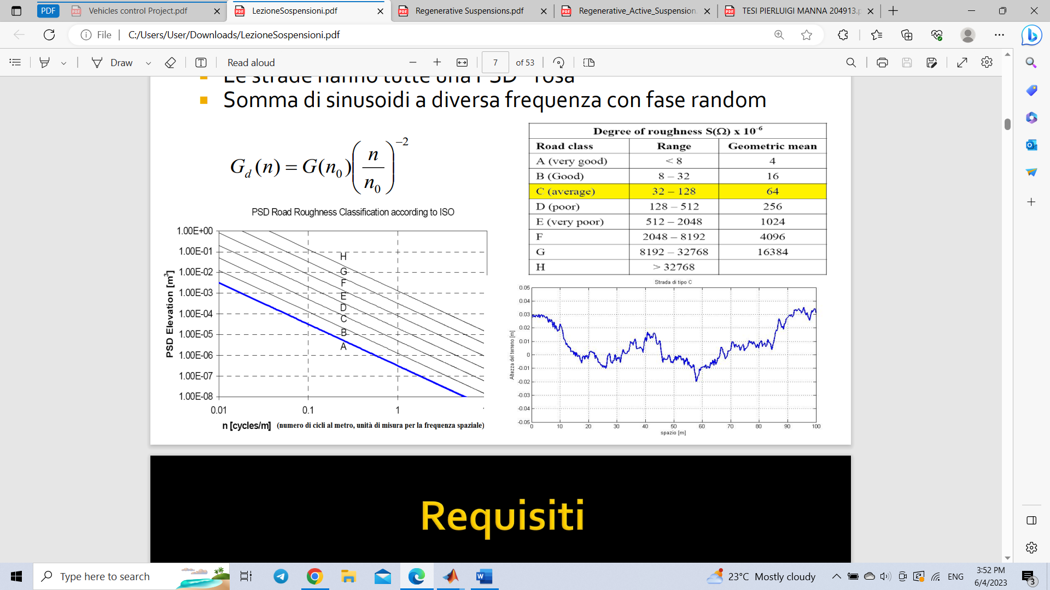

**Fig.2.4.2 Road of type C**

During the project the road of class C is used.

**ISO-2631 standard for ride comfort**

Standardization (ISO) that provides guidelines for assessing human exposure to whole-body vibration and determining its effects on ride comfort, health, and performance. The standard specifically focuses on evaluating the potential adverse effects of mechanical vibration on individuals.

Human perception of vibrations is linked directly to body’s acceleration.

ISO standard for comfort evaluation is as follows:

- Ride index

$$a_{i,RMS}=\sqrt{\frac{1}{T}\int_{0}^{T}{a_{iw}^{2}\left(t\right)dt}}, i=x,y,z$$

Approximate indications of likely reactions to various magnitudes of overall vibration total values in public transport as stated in ISO 2631-1 are illustrated in the following table:

|  |  |
| --- | --- |
| Weighted vibration magnitude (total of three axes) | Likely reaction in public transport |
| Less than 0.315 $m/s^{2}$ | Not uncomfortable |
| 0.315 $m/s^{2}$ to 0.63 $m/s^{2}$ | A little uncomfortable |
| 0.5 $m/s^{2}$ to 1 $m/s^{2}$ | Fairly uncomfortable |
| 0.8 $m/s^{2}$ to 1.6 $m/s^{2}$ | Uncomfortable |
| 1.25 $m/s^{2}$ to 2.5 $m/s^{2}$ | Very uncomfortable |
| Greater than 2 $m/s^{2}$ | Extremely uncomfortable |

1. **System analysis** 
   1. **Internal stability**

The stability of a system can be thought of as a continuity in its dynamic behavior. If there is a small change in the inputs or initial conditions, a stable system will exhibit small changes in its disturbed response. On the other hand, in an unstable system, any disturbance, no matter how small, will cause states or outputs to grow without limit or until the system burns out, disintegrates or becomes saturated. Therefore, stability is a fundamental requirement of dynamic systems intended to perform process operations or signals, and it is the first thing that must be guaranteed in the design of a control system. The criterion chosen to verify the stability of the treated system is the Reduced Lyapunov criterion, which in the continuous case is based on the following statements: 1. If the matrix A has all stable eigenvalues, that is 𝑅(𝜆) < 0, then the system is asymptotically stable. 2. If the matrix has at least one unstable eigenvalue, that is 𝑅 (𝜆) > 0, then the system is unstable. At this point, to verify the assymptotic stability, it is necessary to calculate the eigenvalues of the matrix 𝐴 on MATLAB using the command eig resulting:

$$λ\left(A\right)=\left[\begin{matrix}0.0000 +60.5637i \\ 0.0000 -60.5637i \\ \begin{matrix}-0.0000 +10.2940i \\ -0.0000 -10.2940i\end{matrix}\end{matrix}\right]$$

Clearly, the system is unstable.

* 1. **Structural properties** 
     1. **Reachability**

The reachability property of the system means an existence of a control signal, which transposes the system from zero initial state to any designed final state. The controllability of the system means an existence of a control signal, which transposes the system from any initial state to final zero state. These concepts are equivalent in continuous-time case, so we can consider one of them. Reachability matrix is computed as following,

R = [B AB A2B An-1B]

The system is fully reachable if and only if when the rank of reachability matrix is equal to n, Rank(R)=n

rank(ctrb(A,B))=4

Since, reachability implies controllability, it is possible to say the given system is fully controllable

* + 1. **Observability**

The observability property describes the possibility of estimating the initial state of the system by measuring the output and input over a given time interval.

A system is said to be observable in [t0, t1] if the knowledge of the input-output behavior u [t0, t1], y [t0, t1] uniquely agrees to the initial state x (t0) ∀ u [t0, t1]. That is, there are no x1(t0) and x2(t0) which are indistinguishable.

The observability property is therefore linked to matrices A and C, in fact the observability matrix can be calculated as follows:

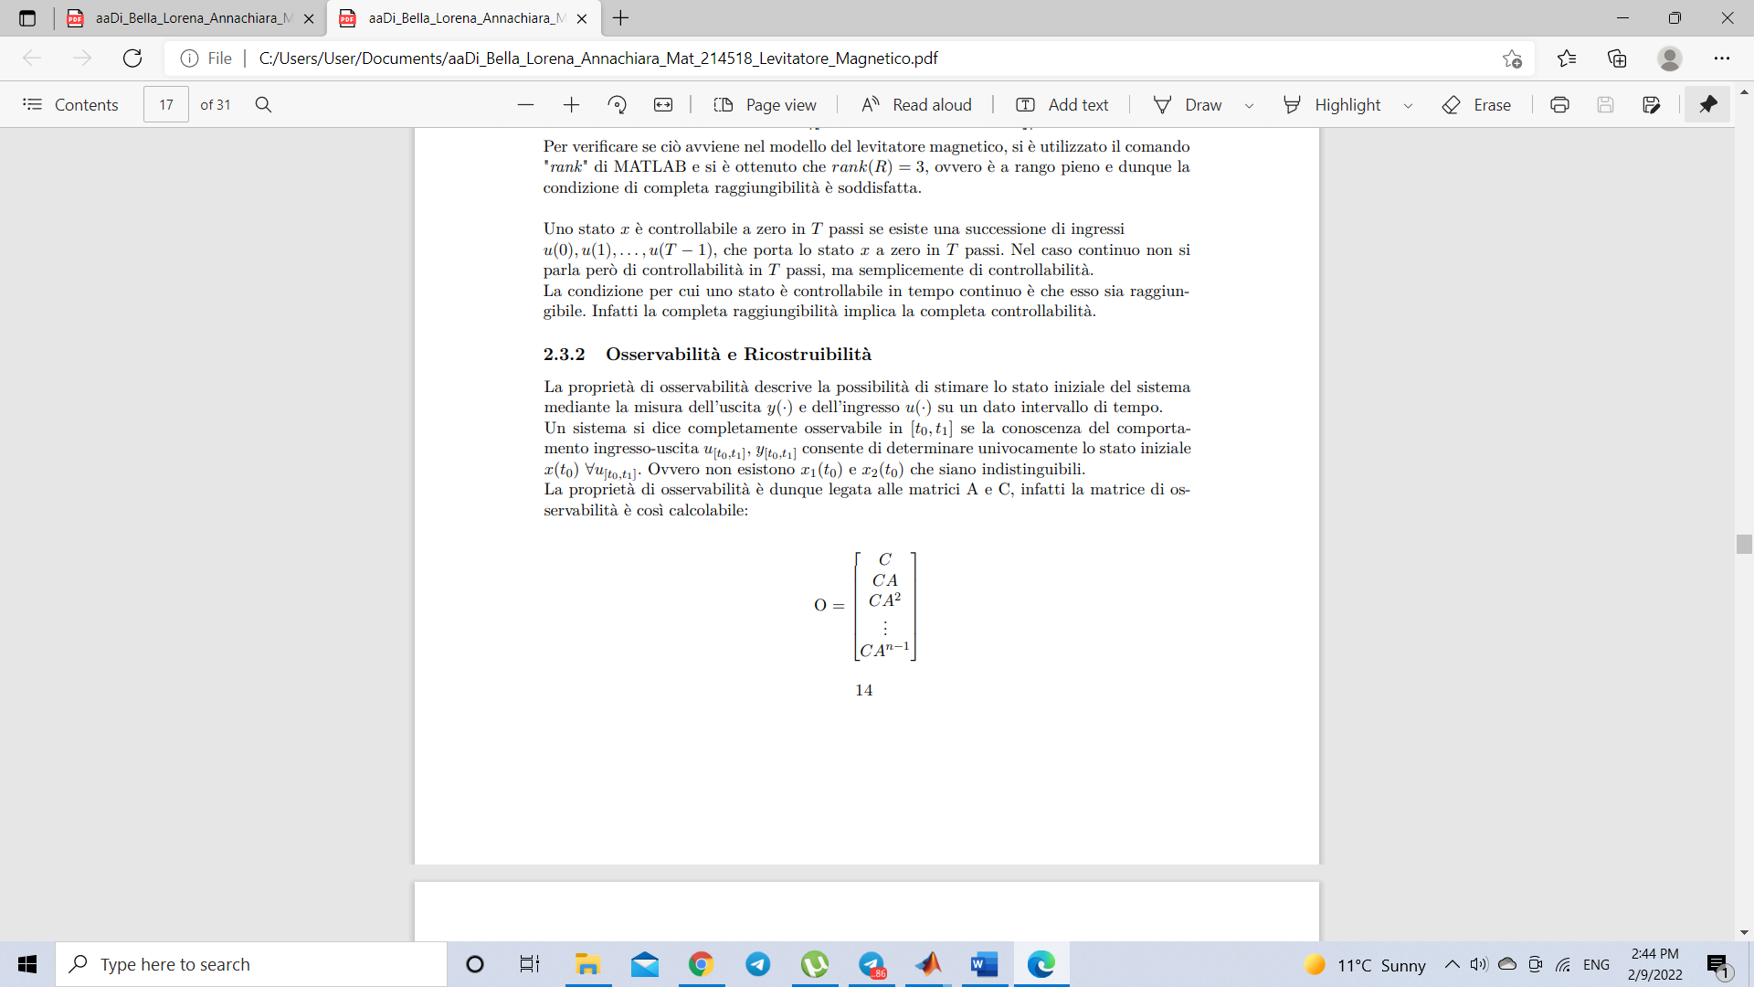

In MATLAB it is possible to calculate it through the command "obsv", which receives as parameters the matrices A and C of the linearized system. Condition of complete observability: "A linear system is completely observable if and only if its observability matrix O has maximum rank, which is rank n". As before, the command "rank" of MATLAB is used to calculate the rank of the matrix O. This allows us to state that the system is completely observable.

Rank (obsv (A, C)) = 4

* 1. **Response in free evolution**

The free response of the system is determined, for null inputs, by applying arbitrary initial conditions. Being a stable system, for any initial condition chosen, it must go into equilibrium conditions, that is, all the state variables must settle at a constant value.

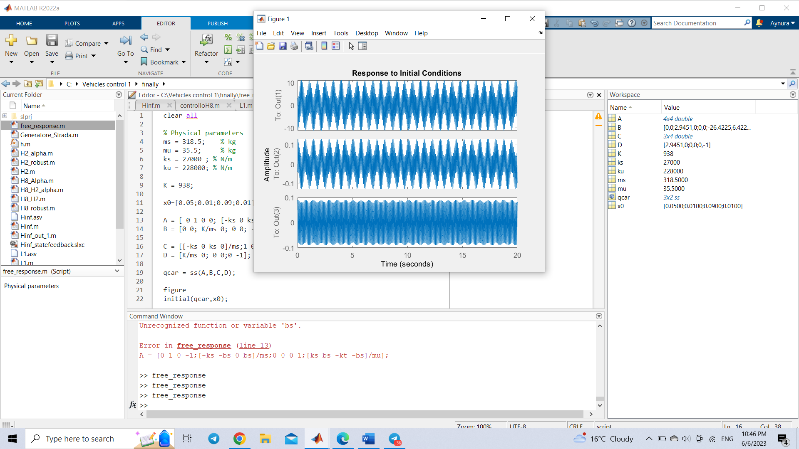

**Fig.3.3. Free response of the system**

The initial condition was considered as $x_{0}=$ [0.05;0.01;0.09;0.01];

As can be seen from the graph, the sprung mass acceleration, suspension stroke and tire deflection oscillate infinitely at high values saying about instability of the system.

1. **Control strategies**

From the analysis phase it was deduced that the system is unstable. Therefore, a force is introduced on suspension making it active. In this chapter, control schemes are proposed to solve the problem of road roughness rejection on the chosen performance outputs.

**Control Design Objectives**

Requirements (all to be minimized) for an active suspension system:

• Ride quality (sprung mass acceleration): ${\ddot{z}}_{s}$

• Road holding (tire deflection): $z_{u}-z_{r}$

• Suspension stroke (distance between sprung and unsprung masses): $z_{s}-z_{u}$

The objectives and matrices are chosen as follows:

$$z=\left[\begin{matrix} {\ddot{z}}_{s} \\ z_{s}-z_{u} \\ \begin{matrix}z_{u}-z_{r} \\ i\end{matrix}\end{matrix}\right], H=\left[\begin{matrix}-\frac{k_{s}}{m_{s}} & 0 & \begin{matrix}\frac{k_{s}}{m_{s}} & 0\end{matrix} \\ 1 & 0 & \begin{matrix}-1 & 0\end{matrix} \\ \begin{matrix}0 \\ 0\end{matrix} & \begin{matrix}0 \\ 0\end{matrix} & \begin{matrix}\begin{matrix}1 \\ 0\end{matrix} & \begin{matrix}0 \\ 0\end{matrix}\end{matrix}\end{matrix}\right] F=\left[\begin{matrix}\frac{K}{m_{s}} \\ 0 \\ \begin{matrix}0 \\ 1\end{matrix}\end{matrix}\right] L=\left[\begin{matrix}0 \\ 0 \\ \begin{matrix}-1 \\ 0\end{matrix}\end{matrix}\right]$$

The goal to be achieved is to provide efficient algorithms for the implementation of a controller K to guarantee asymptotic stability and optimization. In all optimal control problems, we will consider the following extended plant description:

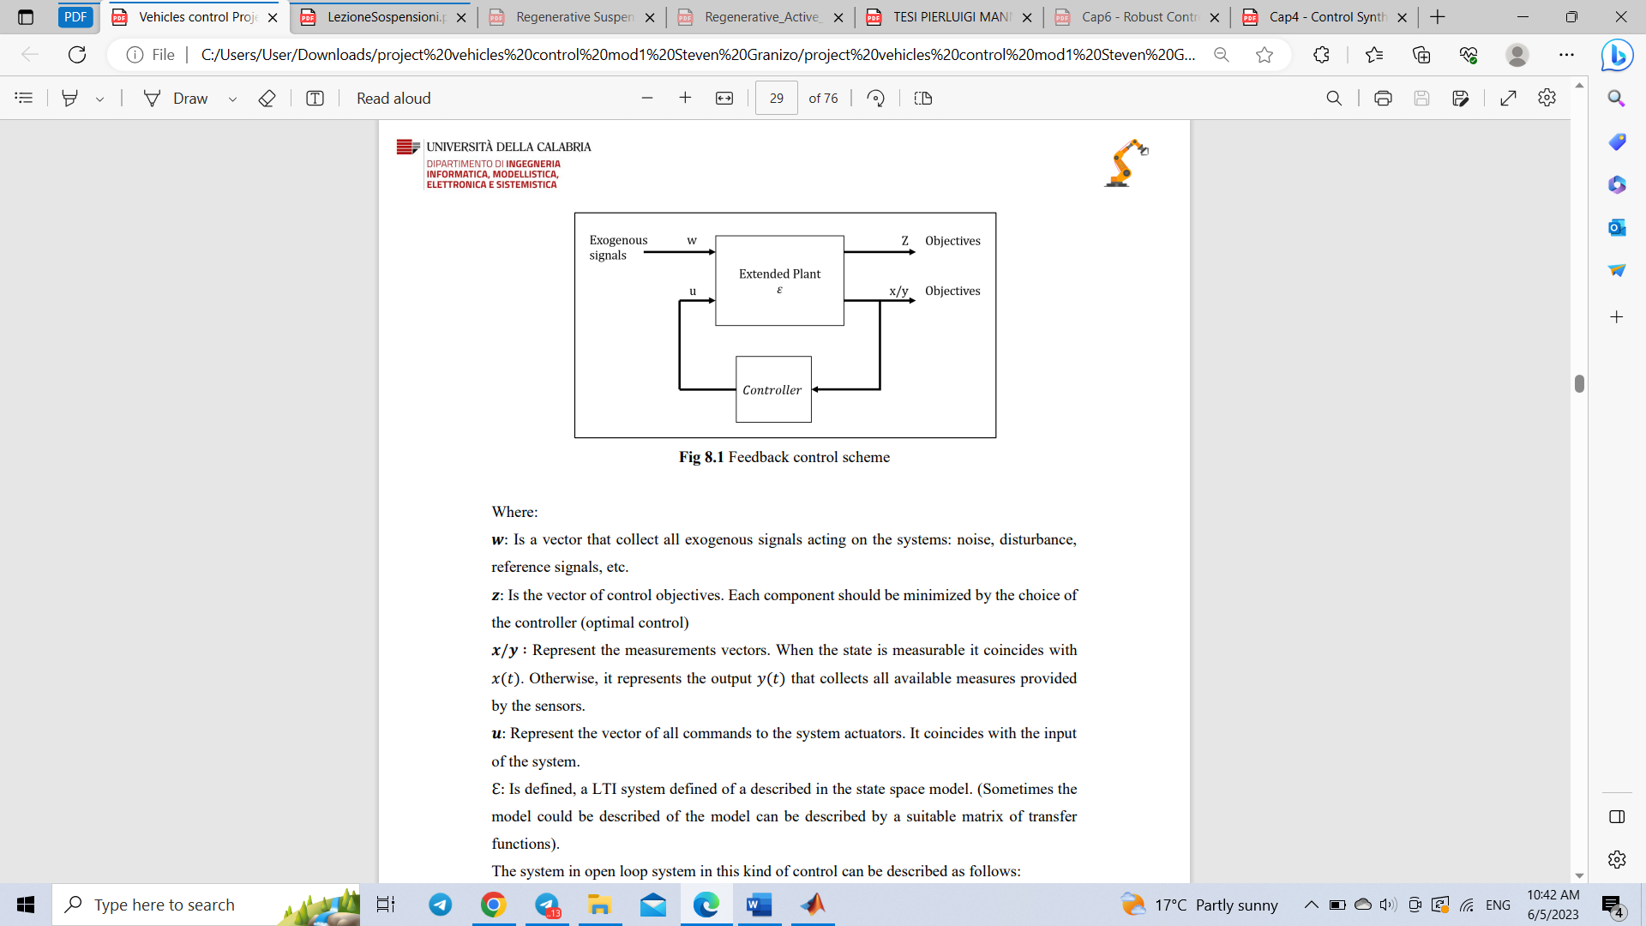

Fig.4.1. General control scheme

where,

𝒘: Is a vector that collect all exogenous signals acting on the systems: noise, disturbance, reference signals. In this project it is road roughness.

𝒛: Is the vector of control objectives. Each component should be minimized by the choice of the controller (optimal control)

𝒙/𝒚 ∶ Represent the measurements vectors, when the state is measurable it coincides with 𝑥(𝑡). Otherwise, it represents the output 𝑦(𝑡) that collects all available measures provided by the sensors.

𝒖: Represent the vector of all commands to the system actuators. It coincides with the input of the system.

ℇ: Extended plant described in the state space model.

* 1. **Filter implementation**

From a practical point of view, it is advantageous to weight in frequency the exogenous signal ${ z}_{r}(t)$ and objectives $z(t)$.

To characterize in frequency the objectives means to specify the relevance to those in different frequency range.

Typically, low-pass filters are used for objectives whereas high-pass filters are used to weight the input.

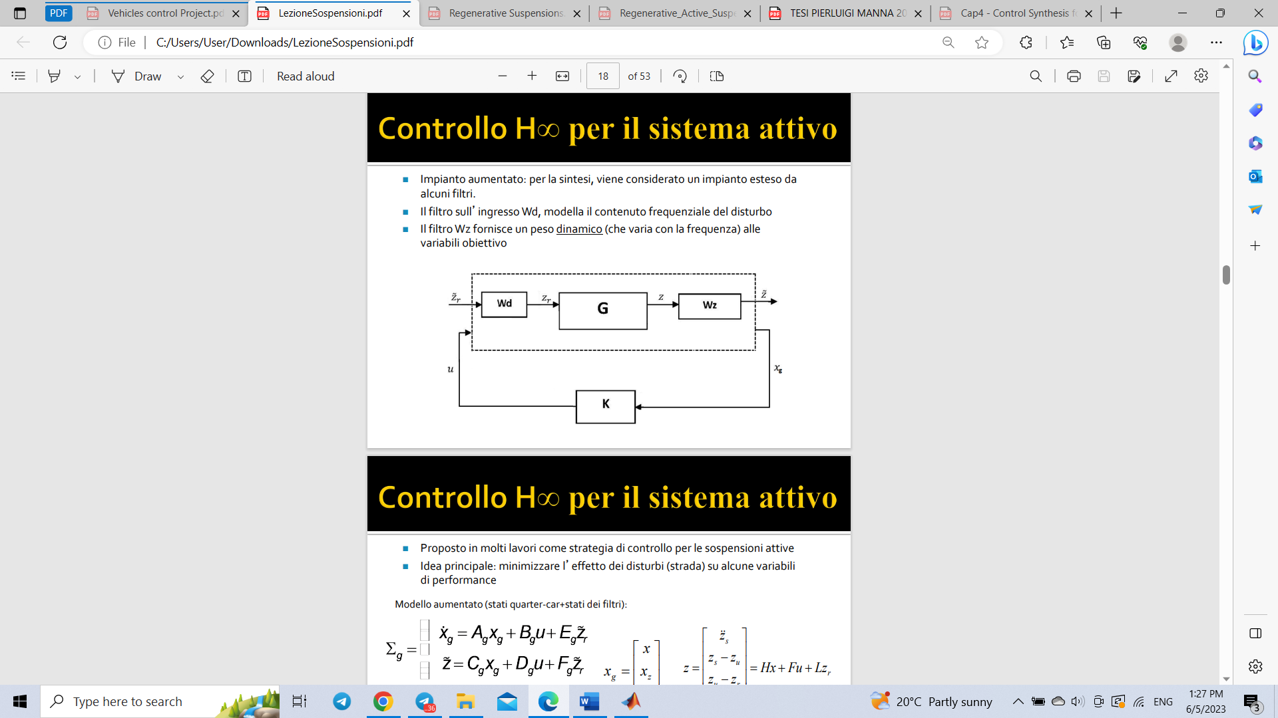

Fig.4.1.1. Augmented scheme with filters

We want to characterize:

$z_{r}$ as output of filter $W_{d}$: $z_{r}=W_{d}(s)\tilde{z_{r}}$

$\tilde{z}$ as output of filter $W_{z}$: $z=W_{z}(s)\tilde{z}$

State-space representation of $W_{d}\left(s\right):$ $\left\{\begin{aligned}\dot{x_{d}}=A_{d}x_{d}+B_{d}\tilde{z_{r}} \\ z_{r}=C_{d}x_{d}+D_{d}\tilde{z_{r}}\end{aligned}\right.$

State-space representation of $W_{z}\left(s\right):$ $\left\{\begin{aligned}\dot{x_{z}}=A_{z}x_{z}+B_{z}z \\ \tilde{z}=C_{z}x_{z}+D_{z}z\end{aligned}\right.$

Filter for the objectives is: $W_{z}=diag\left\{W_{a},W_{e,}W_{t,}W_{u,}\right\}=\left(A_{z},B_{z},C_{z},D_{z}\right)$

Filter for the road roughness is: $W_{d}=\left(A_{d},B_{d},C_{d},D_{d}\right)$

After incorporating filters into state-space model we obtain an augmented model with filters:

$$\left\{\begin{aligned}\dot{x}=A_{g}x_{g}+B_{g}u+E_{g}z_{r} \\ z=C_{g}x_{g}+D_{g}u+F_{g}z_{r}\end{aligned}\right.$$

where,

$$x_{g}=\left[\begin{matrix}x \\ x_{z} \\ x_{d}\end{matrix}\right], A_{g}=\left[\begin{matrix}A & 0 & EC_{d} \\ B_{z}H & A_{z} & B_{z}LC_{d} \\ 0 & 0 & A_{d}\end{matrix}\right], B_{g}=\left[\begin{matrix}B \\ B_{z}F \\ 0\end{matrix}\right], E_{g}=\left[\begin{matrix}ED_{d} \\ {B_{z}LD}_{d} \\ B_{d}\end{matrix}\right]$$

$$C_{g}=\left[\begin{matrix}D_{z}H & C_{z} & D_{z}L\end{matrix}\right], D_{g}=D_{z}F, F_{g}=D_{z}LD_{d}$$

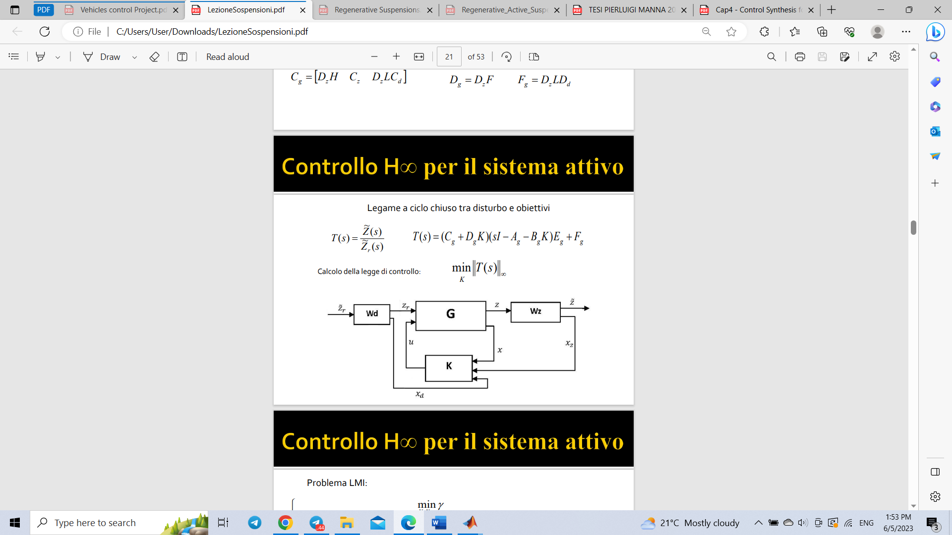

Fig.4.1.2. Augmented control scheme

* 1. **Optimal control**

The system in open loop system can be described as follows:

The control law is a static feedback from the state:

And the equivalent form of this system in closed loop mode is the following:

With closed loop, the transfer matrix is the following:

Notice that depends on the controller gain K and relates:

Where is interpreted as ARMA model (𝑠 = 𝑑/𝑑𝑡, the derivate operator). Then, we must consider the following optimal control design problem:

We have information about the class of input signals that are limited in amplitude, that is, with finite , and we want to obtain an estimate of the maximum amplitude of the output, therefore ${|\left|z_{∞}\left(t\right)\right||}_{2}$. Then, is possible to obtain the following relationship:

$${|\left|z_{∞}\right||}_{2}≤{{||T}_{∞}||}_{H_{∞}}{|\left|z_{r}\right||}_{2}$$

where $K_{∞}^{*}$ is unique controller that makes ${{||T}_{∞}||}_{H_{∞}}$ have the smallest value.

The problem can be solved applying the next LMI configuration:

It is possible to show that there exist a controller $KϵR^{mxn}$ that makes the matrix $(A_{g}+B_{g}K)$ asymptotically stable and ${{||T}_{∞}||}_{H_{∞}}≤γ$ if and only if there exist $X=X^{T}≥0, X ϵ R^{nxn}$ and $Y ϵ R^{mxn}$ such that the following LMI holds true:

$$\left[\begin{matrix}\left(A_{g}X+B_{g}Y\right)+{(A_{g}X+B_{g}Y)}^{T} & E_{g} & {(C_{g}X+D_{g}Y)}^{T} \\ {E_{g}}^{T} & -γI & {F_{g}}^{T} \\ (C_{g}X+D_{g}Y) & F_{g} & -γI\end{matrix}\right]≤0$$

If the solution exist the optimal gain is given by: $K=YX^{-1}$

Then, the optimal $H_{∞}$ controller can be achieved by solving:

$$\left[X^{*},Y^{*}\right]=\underset{X=X^{T},Y}{argmin}{γ}$$

$$\left[\begin{matrix}\left(A_{g}X+B_{g}Y\right)+{\left(A_{g}X+B_{g}Y\right)}^{T} & E_{g} & {\left(C_{g}X+D_{g}Y\right)}^{T} \\ {E_{i}}^{T} & -γI & {F_{g}}^{T} \\ \left(C_{g}X+D_{g}Y\right) & F_{g} & -γI\end{matrix}\right]≤0,$$

$$X>0$$

The optimal $H_{∞}$ optimal controller is given by:

$$K_{∞}^{*}=Y^{*}{X^{*}}^{-1}$$

After solving the abovementioned LMI the following controller gain was obtained and check for asymptotic stability performed:

$$K_{∞}^{*}={10}^{6}*\left[\begin{matrix}-0.0008 & -0.0019 & \begin{matrix}0.7153 & 0.0077 & \begin{matrix}-0.0136 & 0.0002 & \begin{matrix}0.0425 & -2.7517\end{matrix}\end{matrix}\end{matrix}\end{matrix}\right]$$

$$eig\left(A_{g}+B_{g}*K\right)={10}^{5}*\left[\begin{matrix}-0.0512 + 6.0788i \\ -0.0512 - 6.0788i \\ \begin{matrix}-0.0011 + 0.0008i \\ -0.0011- 0.0008i \\ \begin{matrix}-0.0000 + 0.0000i \\ -0.0000+ 0.0000i \\ \begin{matrix}-0.0013 + 0.0000i \\ -0.0002 + 0.0000i\end{matrix}\end{matrix}\end{matrix}\end{matrix}\right]$$

As can be seen, the controller stabilizes the system by minimizing the performance output.

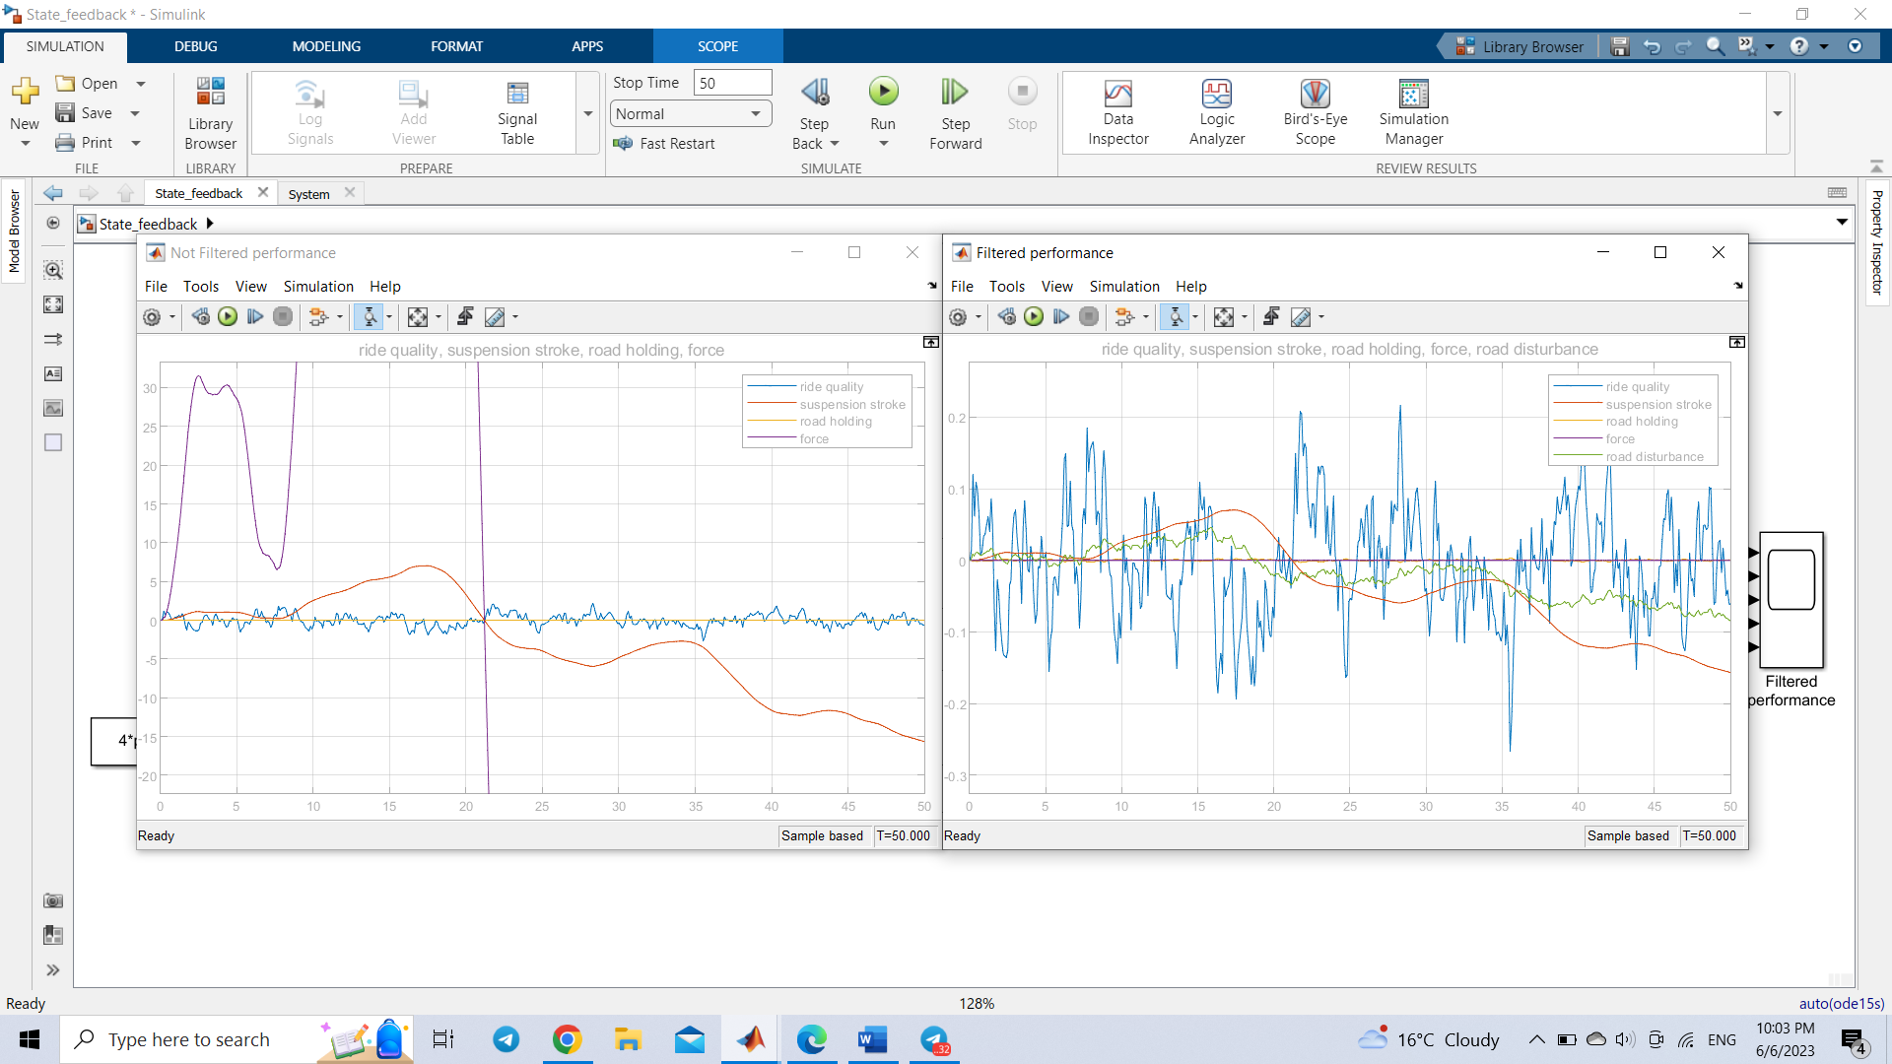

Fig.4.2.1 Not filtered output of $H_{∞}$ optimal controller

This scope represents the result before filtering the signals which have very high values.



Fig.4.2.2 Filtered output of $H_{∞}$ optimal controller

This graph illustrates the result after filtering signals. It possible to observe that ride quality is under 0.3 $\frac{m}{s^{2}}$, meaning that controller was able to reach good performance.

* 1. **Optimal control**

The system in open loop system can be described as follows:

The control law is a static feedback from the state:

And the equivalent form of this system in closed loop mode is the following:

With closed loop, the transfer matrix is the following:

Notice that depends on the controller gain K and relates:

Where is interpreted as ARMA model (𝑠 = 𝑑/𝑑𝑡, the derivate operator). Then, we must consider the following optimal control design problem:

We have information about the class of input signals that are limited in amplitude, that is, with finite , and we want to obtain an estimate of the maximum amplitude of the output, therefore ${|\left|z_{2}\left(t\right)\right||}_{2}$. Then, is possible to obtain the following relationship:

$${|\left|z_{2}\left(t\right)\right||}_{∞}≤{{||T}_{2}||}_{H_{2}}{|\left|z_{r}\right||}_{2}$$

where $K_{∞}^{*}$ is unique controller that makes norm ${{||T}_{2}(s)||}_{H_{2}}$ have the smallest.

The problem can be solved applying the next LMI configuration:

It is possible to show that there exist a controller $KϵR^{mxn}$ that makes the matrix $(A_{g}+B_{g}K)$ asymptotically stable and ${{||T}_{2}||}_{H_{2}}≤ν$ following LMIs holds true:

$$\left[\begin{matrix}\left(A_{g}X+B_{g}Y\right)+{\left(A_{g}X+B_{g}Y\right)}^{T} & E_{g} \\ E_{g}^{T} & -I\end{matrix}\right]≤0$$

$$\left[\begin{matrix}Q & \left(C_{g}X+D_{g}Y\right) \\ {\left(C_{g}X+D_{g}Y\right)}^{T} & X\end{matrix}\right]≥0$$

$$tr\{Q\}<ν^{2}$$

$$X>0$$

Then, the optimal $H_{2}$ controller can be achieved by solving:

$$\left[X^{*},Y^{*}\right]=\underset{X=X^{T},Q=Q^{T},Y}{argmin}{ν^{2}}$$

$$\left[\begin{matrix}\left(A_{g}X+B_{g}Y\right)+{\left(A_{g,i}X+B_{g}Y\right)}^{T} & E_{g} \\ E_{g}^{T} & -I\end{matrix}\right]≤0$$

$$\left[\begin{matrix}Q & \left(C_{g}X+D_{g}Y\right) \\ {\left(C_{g}X+D_{g}Y\right)}^{T} & X\end{matrix}\right]≥0$$

$$tr\left\{Q\right\}<ν^{2}$$

$$X>0$$

The optimal $H_{2}$ controller is given by:

$$K_{2}^{*}=Y^{*}{X^{*}}^{-1}$$

After solving the abovementioned LMI the following controller gain was obtained and check for asymptotic stability performed:

$$K={10}^{4}*\left[\begin{matrix}0.0002 & -0.0015 & \begin{matrix}-0.0004 & 0 & \begin{matrix}-0.4785 & 0 & \begin{matrix}2.5128 & 0\end{matrix}\end{matrix}\end{matrix}\end{matrix}\right]$$

$$eig\left(A_{g}+B_{g}*K\right)={10}^{5}*\left[\begin{matrix}-1.2631 + 2.0131i \\ -1.2631 - 2.0131i \\ \begin{matrix}-0.0000 + 0.0008i \\ -0.0000- 0.0008i \\ \begin{matrix}-0.0000 + 0.0000i \\ -0.0000- 0.0000i \\ \begin{matrix}-0.0013 + 0.0000i \\ -0.0002 + 0.0000i\end{matrix}\end{matrix}\end{matrix}\end{matrix}\right]$$

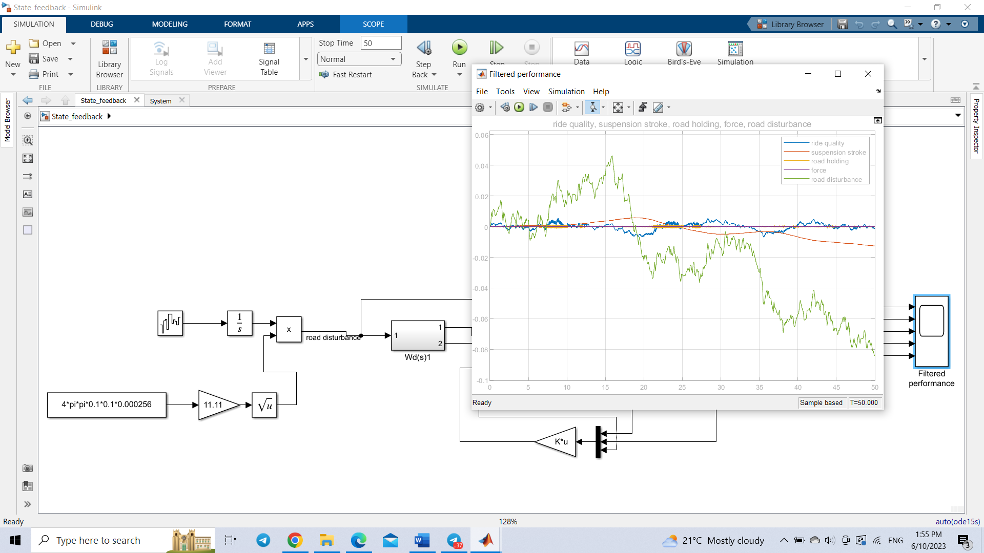

Fig.4.3. Filtered output of $H_{2}$ optimal controller

As can be seen, the controller stabilizes the system by minimizing the performance output.

* 1. **Multi-objective control**
     1. $H_{∞}-α$**stability Control**

The $H_{∞}-α$ stability control is a multi-objective control that allows to improve the performance of the control by simply placing the poles to the left of pole 𝑠 = −𝑎 with 𝑎 > 0. In this way, the system states will tend asymptotically to their equilibrium point without any oscillatory character, since the system modes will have only the real part negative and different from while the imaginary part will be zero. In terms of LMI, this translates into adding more constraints to the $H_{∞}$ problem solved in terms of LMI. Specifically, the poles have been assumed to lie in the left half-plane bounded by the line 𝑠 = −𝑎 by inserting the following constraint:

In addition to the following restriction, the poles were imposed to be within the sector delimited by the straight lines having an angular coefficient equal to $±θ:$

$$\left[\begin{matrix}(AX+BY+{(AX+BY)}^{T})\sin{θ} & -(AX+BY+{(AX+BY)}^{T})\cos{θ} \\ (AX+BY+{(AX+BY)}^{T})\cos{θ} & (AX+BY+{(AX+BY)}^{T})\sin{θ}\end{matrix}\right]<0$$

Now, it is possible to establish the problem in the LMI form in the following way:

$$\left[\begin{matrix}\left(A_{g}X+B_{g}Y\right)+{\left(A_{g}X+B_{g}Y\right)}^{T} & E_{g} & {\left(C_{g}X+D_{g}Y\right)}^{T} \\ {E_{g}}^{T} & -γI & {F_{g}}^{T} \\ \left(C_{g}X+D_{g}Y\right) & F_{g} & -γI\end{matrix}\right]≤0$$

$$2αX+AX+BY+{\left(AX+BY\right)}^{T}<0$$

$$\left[\begin{matrix}\left(AX+BY+{\left(AX+BY\right)}^{T}\right)\sin{θ} & -\left(AX+BY+{\left(AX+BY\right)}^{T}\right)\cos{θ} \\ \left(AX+BY+{\left(AX+BY\right)}^{T}\right)\cos{θ} & \left(AX+BY+{\left(AX+BY\right)}^{T}\right)\sin{θ}\end{matrix}\right]<0$$

$$\left[\begin{matrix}-rX & AX+BY \\ {(AX+BY)}^{T} & -rX\end{matrix}\right]<0$$

$$X>0$$

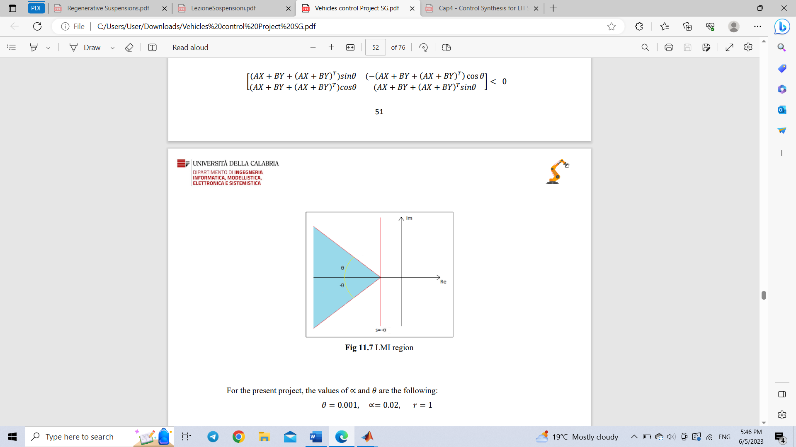

Fig.4.4.1.1. $α-$ stability control scheme

After solving the abovementioned LMI the following controller gain was obtained and check for asymptotic stability performed:

$$K={10}^{3}*\left[\begin{matrix}-0.2565 & -0.0721 & \begin{matrix}2.9428 & 0.0681 & \begin{matrix}-0.1694 & 0.0021 & \begin{matrix}-0.0001 & -7.4769\end{matrix}\end{matrix}\end{matrix}\end{matrix}\right]$$

$$eig\left(A_{g}+B_{g}*K\right)={10}^{6}*\left[\begin{matrix}-1.0000 + 0.0000i \\ -0.0014 + 0.0000i \\ \begin{matrix}-0.0000 + 0.0000i \\ -0.0000- 0.0000i \\ \begin{matrix}-0.0001 + 0.0000i \\ -0.0001 + 0.0000i \\ \begin{matrix}-0.0001 + 0.0000i \\ -0.0000 + 0.0000i\end{matrix}\end{matrix}\end{matrix}\end{matrix}\right]$$

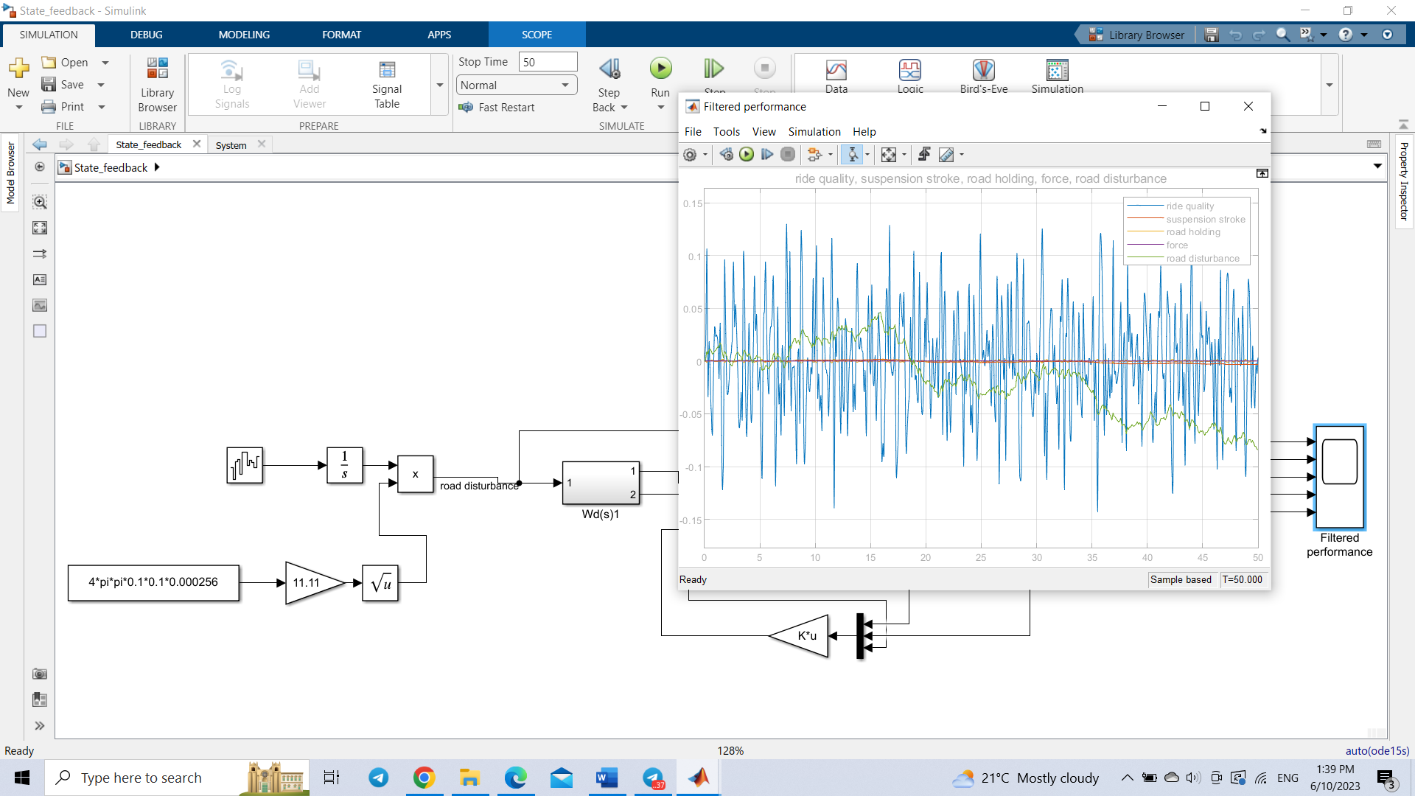

Fig.4.4.1.2. Filtered output of $H_{∞}-α$

As can be seen from the graph, the controller stabilizes the system by minimizing the performance output and the performance is improved compared to $H_{∞}$ control.

* + 1. **stability Control**

The stability control is a multi-objective control that allows to improve the performance of the control by simply placing the poles to the left of pole 𝑠 = −𝑎 with 𝑎 > 0. In this way, the system states will tend asymptotically to their equilibrium point without any oscillatory character, since the system modes will have only the real part negative and different from while the imaginary part will be zero. In terms of LMI, this translates into adding more constraints to the 𝐻∞ problem solved in terms of LMI. Specifically, the poles have been assumed to lie in the left half-plane bounded by the line 𝑠 = −𝑎 by inserting the following constraint:

In addition to the following restriction, the poles were imposed to be within the sector delimited by the straight lines having an angular coefficient equal to $±θ:$

$$\left[\begin{matrix}(AX+BY+{(AX+BY)}^{T})\sin{θ} & -(AX+BY+{(AX+BY)}^{T})\cos{θ} \\ (AX+BY+{(AX+BY)}^{T})\cos{θ} & (AX+BY+{(AX+BY)}^{T})\sin{θ}\end{matrix}\right]<0$$

Now, is possible to stablish the problem in the LMI form in the following way:

$$\left[\begin{matrix}\left(A_{g}X+B_{g}Y\right)+{\left(A_{g}X+B_{g}Y\right)}^{T} & E_{g} \\ E_{g}^{T} & -I\end{matrix}\right]≤0$$

$$\left[\begin{matrix}Q & \left(C_{g}X+D_{g}Y\right) \\ {\left(C_{g}X+D_{g}Y\right)}^{T} & X\end{matrix}\right]≥0$$

$$tr\left\{Q\right\}<ν^{2}$$

$$2αX+AX+BY+{\left(AX+BY\right)}^{T}<0$$

$$\left[\begin{matrix}\left(AX+BY+{\left(AX+BY\right)}^{T}\right)\sin{θ} & -\left(AX+BY+{\left(AX+BY\right)}^{T}\right)\cos{θ} \\ \left(AX+BY+{\left(AX+BY\right)}^{T}\right)\cos{θ} & \left(AX+BY+{\left(AX+BY\right)}^{T}\right)\sin{θ}\end{matrix}\right]<0$$

$$X>0$$

After solving the abovementioned LMI the following controller gain was obtained and check for asymptotic stability performed:

$$K={10}^{4}*\left[\begin{matrix}-0.0372 & -0.0128 & \begin{matrix}-0.1644 & 0.0345 & \begin{matrix}-0.1383 & -0.0000 & \begin{matrix}2.0275 & 4.0178\end{matrix}\end{matrix}\end{matrix}\end{matrix}\right]$$

$$eig\left(A_{g}+B_{g}*K\right)={10}^{5}*\left[\begin{matrix}-2.8713 + 0.0000i \\ -0.9005 + 0.0000i \\ \begin{matrix}-0.0006 + 0.0000i \\ -0.0000- 0.0000i \\ \begin{matrix}-0.0001 + 0.0000i \\ -0.0001 + 0.0000i \\ \begin{matrix}-0.0001 + 0.0000i \\ -0.0000 + 0.0000i\end{matrix}\end{matrix}\end{matrix}\end{matrix}\right]$$

As can be seen, the controller stabilizes the system by minimizing the performance output.

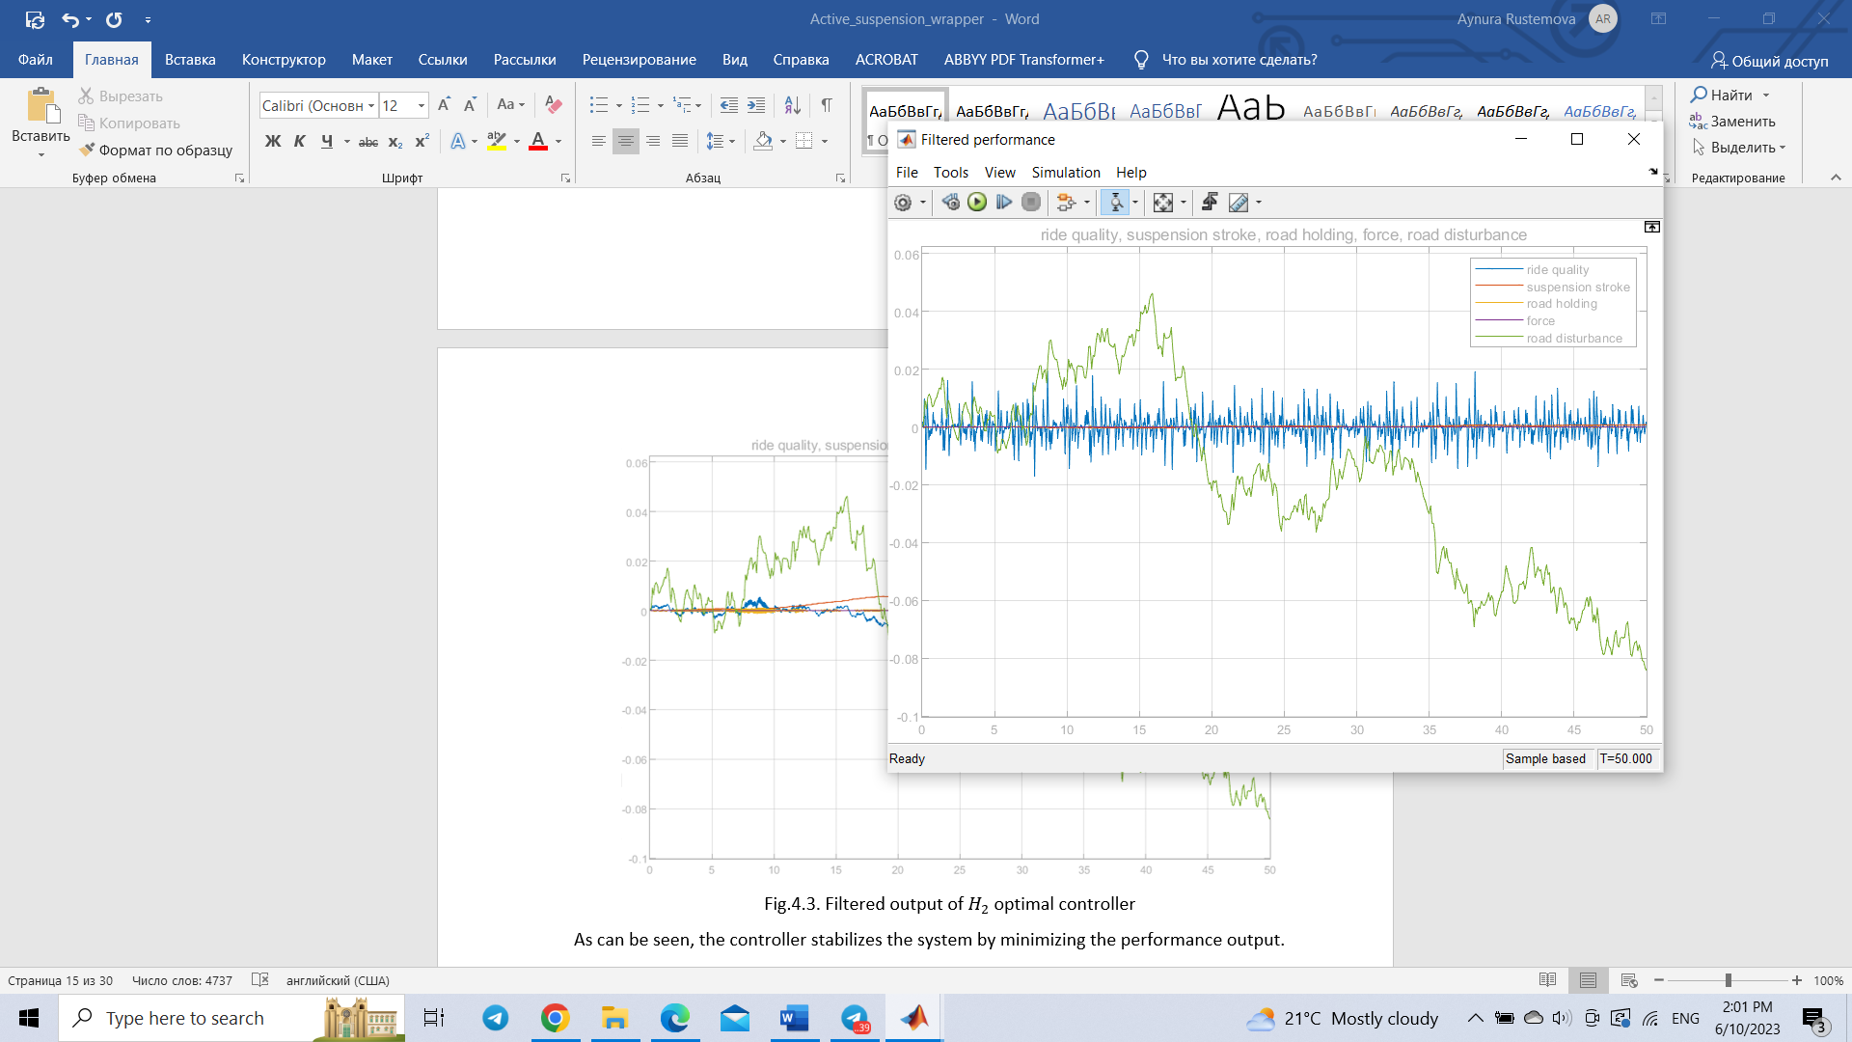

Fig.4.4.2. Filtered output of $H_{2}-α$ control

* 1. **Robust control**

The theory of Robust Control encompasses the notion of an "Uncertain dynamical system" in control. Model uncertainty refers to the variations in behavior between the actual system and its model.

Robust Control involves designing a control law that can guarantee stability and performance across all admissible uncertainty levels, based on a given model and its mathematical description of uncertainty.

The key features of such controllers are as follows:

• Robust control exhibits diminished performance compared to optimal control in the case of Linear Time-Invariant (LTI) systems.

• The better the uncertainty is characterized, the higher the performance will be.

• Uncertainty can be time varying or time invariant, static, or dynamic, linear or non-linear, etc.

The principal causes of model uncertainty are:

**Non-parametric (Dynamic) Uncertainty**

Most of the time derives from ruling out from the model dynamic behaviors that are considered negligible.

**Parametric Uncertainty**

In this case, we know the transfer function or a state-space representation of the system. Moreover, we know that some parameters of the system are uncertain.

State-Space representation of uncertain models

**Affine models:**

$$\left\{\begin{aligned}\dot{x}\left(t\right)=Ax\left(t\right)+Bu\left(t\right) \\ y\left(t\right)=Cx\left(t\right)+Du\left(t\right)\end{aligned}, x\left(0\right)=x_{0}\right.$$

$$A∈R^{n×n},B∈R^{n×m},C∈R^{p×n},D∈R^{p×m}$$

where the matrices A, B, C, D depends now on vector 𝑝 ∈ $R^{l}$ of uncertain parameters.

$$p=\left[\begin{matrix}p_{1} \\ p_{2} \\ \begin{matrix}⋮ \\ p_{l}\end{matrix}\end{matrix}\right]$$

In an affine way, that is:

$$A\left(p\right)=A_{0}+p_{1}A_{1}+…+p_{l}A_{l}$$

$$B\left(p\right)=B_{0}+p_{1}B_{1}+…+p_{l}B_{l}$$

$$C\left(p\right)=C_{0}+p_{1}C_{1}+…+p_{l}C_{l}$$

$$D\left(p\right)=D_{0}+p_{1}D_{1}+…+p_{l}D_{l}$$

**Polytopic models: $$\left\{\begin{aligned}\dot{x}\left(t\right)=Ax\left(t\right)+Bu\left(t\right) \\ y\left(t\right)=Cx\left(t\right)+Du\left(t\right)\end{aligned}, x\left(0\right)=x_{0}\right.$$**

$$p=\left[\begin{matrix}p_{1} \\ p_{2} \\ \begin{matrix}⋮ \\ p_{l}\end{matrix}\end{matrix}\right], 0{≤p}_{i}≤1, \sum_{i=1}^{l}{p_{i}}=1$$

where the matrices A, B, C, D are defined as convex combination of given matrices:

$$A\left(p\right)=p_{1}A_{1}+p_{2}A_{2}+…+p_{l}A_{l}$$

$$B\left(p\right)=p_{1}B_{1}+p_{2}B_{2}+…+p_{l}B_{l}$$

$$C\left(p\right)=p_{1}C_{1}+p_{2}C_{2}+…+p_{l}C_{l}$$

$$D\left(p\right)=p_{1}D_{1}+p_{2}D_{2}+…+p_{l}D_{l}$$

Notice that 𝐴(𝑝) is a convex family of $n×n$ matrices and $A_{1},A_{2}…A_{l}$ are called the vertices of 𝑨(𝒑).

* + 1. **Robust control**

In this project only the polytopic uncertain model is used for the sake of simplicity and the system in open loop in this case is: $$\left\{\begin{aligned}\dot{x}=A_{g}x_{g}+B_{g}u+E_{g}z_{r} \\ z_{∞}=C_{g}x_{g}+D_{g}u+F_{g}z_{r}\end{aligned}\right.$$

Under the stabilizing state-feedback controller $u=Kx,$ the closed-loop form takes the following form:

$$\left\{\begin{aligned}\dot{x}=\left(A_{g}+B_{g}K\right)x_{g}+E_{g}z_{r} \\ z_{∞}=(C_{g}+D_{g}K)x_{g}+F_{g}z_{r}\end{aligned}\right.$$

In uncertain case, the closed-loop transfer matrix $T_{∞}\left(s\right)$ is not well defined because also depends on parameter $p$. Moreover, the induced gain to be used or cost function in the various control synthesis problems, depend on $p$ as well. So, in this case we speak of Worst-case-cost. Worst-case $H_{∞}:$

$${|\left|T_{∞}\right||}_{H_{∞}}^{wc}≜\sup_{w∈L_{2},p∈1}{\frac{{{||z}_{∞}||}_{2}}{{|\left|w\right||}_{2}}}$$

Notice that when minimizing the worst case, induced gain consists of minimizing the cost of the worst case. Then, we can define the following robust synthesis problem:

$$H_{∞} Robust control: K_{∞}^{*}=arg\min_{kϵS}{{\left|\left|T_{∞}\right|\right|}_{H_{∞}}^{wc}}$$

It is possible to show that there exist a controller $K∈R^{mxn}$ that makes the matrix $(A_{g}(p)+B_{g}(p)K)$ robustly quadratically stable and ${|\left|T_{∞}\right||}_{H_{∞}}^{wc}≤γ$ if and only if there exist $X=X^{T}≥0, X ϵ R^{nxn}$ and $Y ϵ R^{mxn}$ such that the following LMI holds true:

$$\left[\begin{matrix}\left(A_{g,i}X+B_{g,i}Y\right)+{(A_{g,i}X+B_{g,i}Y)}^{T} & E_{g,i} & {(C_{g,i}X+D_{g,i}Y)}^{T} \\ {E_{g,i}}^{T} & -γI & {F_{g,i}}^{T} \\ (C_{g,i}X+D_{g,i}Y) & F_{g,i} & -γI\end{matrix}\right]≤0$$

$$i=1,2…l$$

If the solution exist the optimal gain is given by: $K=YX^{-1}$

Then, the optimal $H_{∞}$ robust controller can be achieved by solving:

$$\left[X^{*},Y^{*}\right]=\underset{X=X^{T},Y}{argmin}{γ}$$

$$\left[\begin{matrix}\left(A_{g,i}X+B_{g,i}Y\right)+{\left(A_{g,i}X+B_{g,i}Y\right)}^{T} & E_{g,i} & {\left(C_{g,i}X+D_{g,i}Y\right)}^{T} \\ {E_{g,i}}^{T} & -γI & {F_{g,i}}^{T} \\ \left(C_{g,i}X+D_{g,i}Y\right) & F_{g,i} & -γI\end{matrix}\right]≤0,$$

$$X>0$$

The $H_{∞}$ robust controller is given by:

$$K_{∞}^{*}=Y^{*}{X^{*}}^{-1}$$

**Parametric uncertainty modeling**

The values of the controller gains at each working point are possible to perform the following analogy:

$$\underline{m_{s}}≤m_{s}\left(t\right)≤\overline{m_{s}}$$

Where: $m_{s}\left(t\right)$,are uncertain parameters but limited in a known range, in this project it is sprung mass weight $200≤m_{s}\left(t\right)≤400$. It should be noted that it can be constant or time-varying, being in this case time-varying. Consequently, the dynamic matrix A also becomes uncertain:

$$A(m_{s}\left(t\right))$$

An algebraic manipulation is implemented to then use the polytopic model, moving from uncertain parameters that varying between a generic minimum and maximum value to others:

$$p_{1}\left(t\right),p_{2}\left(t\right)∈Π_{2}=\left\{p | 0≤p_{1}\left(t\right),p_{2}\left(t\right)≤1,p_{1}\left(t\right)+p_{2}\left(t\right)=1\right\}$$

$$p\left(t\right)=\frac{m_{s}-\underline{m_{s}}}{\overline{m_{s}}-\underline{m_{s}}}$$

But the dependence with the original uncertain quantities is:

$$m_{s}\left(t\right)=\overline{m_{s}}p_{1}\left(t\right)+\underline{m_{s}}\left(1-p_{1}\left(t\right)\right)$$

Therefore, the open loop system will be:

Matrix $A$ can be written as follows:

$$A\left(p\right)=p_{1}A_{1}+\left(1-p_{1}\right)A_{2}$$

After solving the abovementioned LMI the following controller gain was obtained and check for robust quadratically stability performed:

$$K_{∞}^{*}={10}^{4}*\left[\begin{matrix}-0.0002 & -0.0014 & \begin{matrix}0.4216 & 0.0051 & \begin{matrix}-0.0139 & 0.0001 & \begin{matrix}2.8762 & -1.4167\end{matrix}\end{matrix}\end{matrix}\end{matrix}\right]$$

$$eig\left(A_{g}+B_{g}*K\right)={10}^{4}*\left[\begin{matrix}-4.1381 + 3.6298i \\ -4.1381- 3.6298i \\ \begin{matrix} -0.0089 + 0.0083i \\ -0.0089- 0.0083i \\ \begin{matrix}-0.0000 + 0.0000i \\ -0.0001 + 0.0000i \\ \begin{matrix}-0.0126 + 0.0000i \\ -0.0020 + 0.0000i\end{matrix}\end{matrix}\end{matrix}\end{matrix}\right]$$

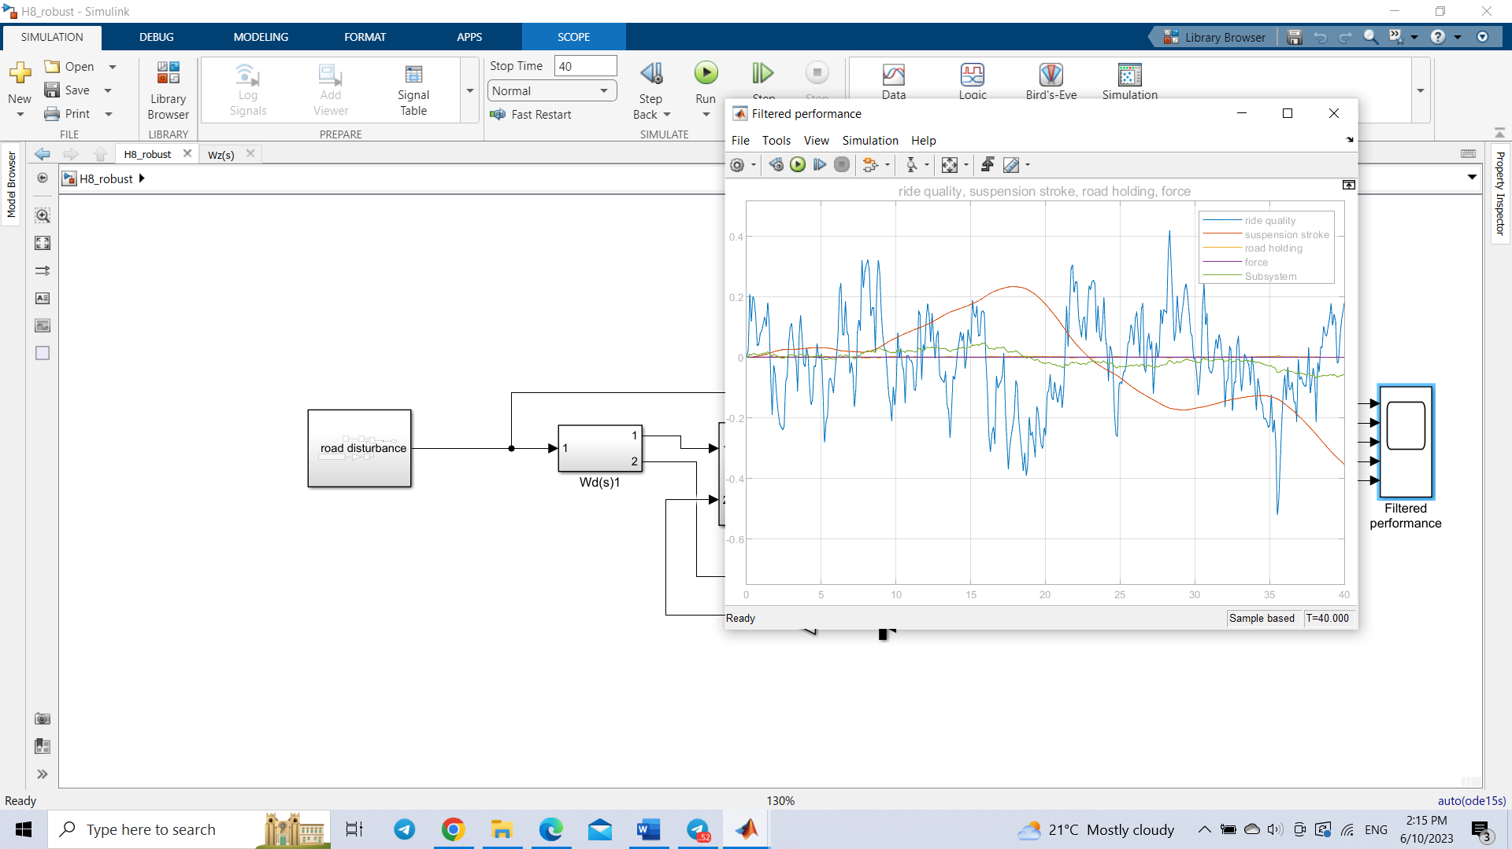

Fig.4.5.1. Filtered output of $H_{∞}$ Robust control

As expected, the performance is a bit reduced compared to the performance of optimal control. But still designed optimal robust controller is able to keep the ride quality under 0.3m/s2.

* 1. **Linear parameter varying systems and gain-scheduling control**

Gain-scheduling control strategies are suggested as a viable approach to enhance the limited effectiveness of robust control when it comes to regulating nonlinear systems across various operating conditions. The primary goal is to utilize all the available information about the present operating condition of the system by implementing supplementary techniques that can dynamically adjust the controller's parameters and its behavior.

+ u(t) y(t)

Plant

-

G-S controller

Fig.4.6. Gain-scheduling control scheme

The general State-Space representation of the LPV control is the following:

$$\left\{\begin{aligned}\dot{x}\left(t\right)=A(p(t))x\left(t\right)+B(p\left(t\right))u\left(t\right) \\ y\left(t\right)=C(p\left(t\right))x\left(t\right)+D(p\left(t\right))u\left(t\right)\end{aligned}, x\left(0\right)=x_{0}\right.$$

Where 𝒑(𝒕) is a vector of parameters that can be measured on-line. Notice that valid parameters do not include components of 𝑥(𝑡), 𝑢(𝑡) and 𝑦(𝑡).

Classical Gain-Scheduling design approach:

1. 𝑥̇ = 𝑥 + 𝑢, 𝑖 = 1,2, … , 𝑆 Non-linear system linearized around .

2. 𝑢(𝑡) = 𝑥(𝑡), 𝑖 = 1,2, … , 𝑆 is designed based on ( , )

3. Use the following gain-scheduling control laws:

𝑢(𝑡) = 𝐾(𝑝(𝑡))𝑥(𝑡)

$$K(p\left(t)\right)=\sum_{i=1}^{s}{p_{i}\left(t\right)k_{i}}$$

where

$$\left[A\left(p\right) B\left(p\right)\right]=\sum_{i=1}^{s}{p_{i}\left[A_{i }B_{i}\right]}$$

$$0≤p_{i}≤1, \sum_{i=1}^{s}{p_{i}=1}$$

It should be noted that the conventional approach carries inherent risks as it does not provide a guarantee for the overall asymptotic stability of nonlinear systems. This is because time-varying factors can come into play and disrupt stability.

1. 𝑃 is a compact set of ${R }^{s}$
2. p(𝑡) is a piecewise-continuous function of 𝑡
3. 𝐴(𝑝), 𝐵(𝑝), 𝐶(𝑝), 𝐷(𝑝) are matrices-valued continuous functions of 𝑝.

**Optimal $H_{∞}$ gain-scheduling control**

The open loop system can be expressed as follow

$$\left\{\begin{aligned}\dot{x}=A_{g}(p)x_{g}+B_{g}(p)u+E_{g}(p)z_{r} \\ z_{∞}=C_{g}(p)x_{g}+D_{g}(p)u+F_{g}(p)z_{r}\end{aligned}\right.$$

𝑢(𝑡) = 𝐾(𝑝(𝑡))𝑥(𝑡)

$$K(p\left(t\right)=\sum_{i=1}^{s}{p_{i}\left(t\right)k_{i}}$$

Where

$$\left[A\left(p\right) B\left(p\right)\right]=\sum_{i=1}^{s}{p_{i}\left[A_{i }B_{i}\right]}$$

$$0≤p_{i}≤1, \sum_{i=1}^{s}{p_{i}=1}$$

Then, the closed loop system becomes:

$$\left\{\begin{aligned}\dot{x}={[A}_{g}(p)+B_{g}\left(p\right)K(p)]x_{g}+E_{g}(p)z_{r} \\ z_{∞}={[C}_{g}(p)+D_{g}(p)K(p)]x_{g}+F_{g}(p)z_{r}\end{aligned}\right.$$

Analogously to the robust synthesis, is possible to define the worst-case induced gains in closed loop. So, in this case the worst-case $H_{∞}$ is:

The above induced gain is a convex function of the controller 𝑘(𝑝) and $T_{∞}(p,s)$ is the closed loop transfer matrix. Then, we consider the following optimal LPV synthesis problem:

$$H_{∞} optimal LPV control: K_{∞}^{*}(p)=arg\min_{k(p)ϵS}{{\left|\left|T_{∞}\right|\right|}_{H_{∞}}^{wc}}$$

It is possible reformulated this polytopic uncertain system under gain-scheduling statefeedback control laws:

$∃ K\left(p\right)=\sum_{j=1}^{s}{p_{j}K_{j}}$ s.t the closed loop system is quadratically stable $∀ p∈1$ and ${\left|\left|T_{∞}\right|\right|}_{H_{∞}}^{wc}<γ$ if $∃ X=X^{T}>0, ∃ Y_{j}, j=1,2…s$ such that

$$\left[\begin{matrix}\left(A_{g,i}X+B_{g,i}Y_{j}\right)+{\left(A_{g,i}X+B_{g,i}Y_{j}\right)}^{T} & E_{g,i} & {\left(C_{g,i}X+D_{g,i}Y_{j}\right)}^{T} \\ {E_{g,i}}^{T} & -γI & {F_{g,i}}^{T} \\ \left(C_{g,i}X+D_{g,i}Y_{j}\right) & F_{g,i} & -γI\end{matrix}\right]≤0, i,j=1,2…s$$

The stabilizing controller is given by:

$$K\left(p\right)=\sum_{j=1}^{s}{p_{j}Y_{j}}X^{-1}$$

The optimal $H_{∞}$ gain-scheduling control is the following:

$$\left[X^{*},{Y_{j}}^{*}\right]=\underset{X=X^{T},Y}{argmin}{γ}$$

$$\left[\begin{matrix}\left(A_{g,i}X+B_{g,i}Y_{j}\right)+{\left(A_{g,i}X+B_{g,i}Y_{j}\right)}^{T} & E_{g,i} & {\left(C_{g,i}X+D_{g,i}Y_{j}\right)}^{T} \\ {E_{g,i}}^{T} & -γI & {F_{g,i}}^{T} \\ \left(C_{g,i}X+D_{g,i}Y_{j}\right) & F_{g,i} & -γI\end{matrix}\right]≤0,$$

$$X>0$$

$$i,j=1,2…s$$

The $H_{∞}$ optimal LPV control is given by:

$$K_{∞}^{*}\left(p\right)=\sum_{j=1}^{s}{p_{j}Y_{j}^{*}}{X^{*}}^{-1},$$

$p=\left[p_{1}\left(t\right), p_{2}\left(t\right)… p_{s}\left(t\right)\right]$ measurable $∀ t$

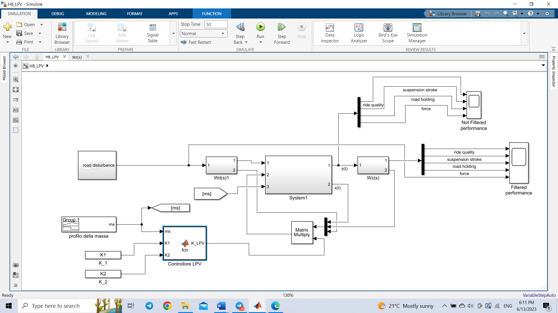

Fig.4.6.2. Overall scheme of $H_{∞}$ optimal LPV controller in Simulink

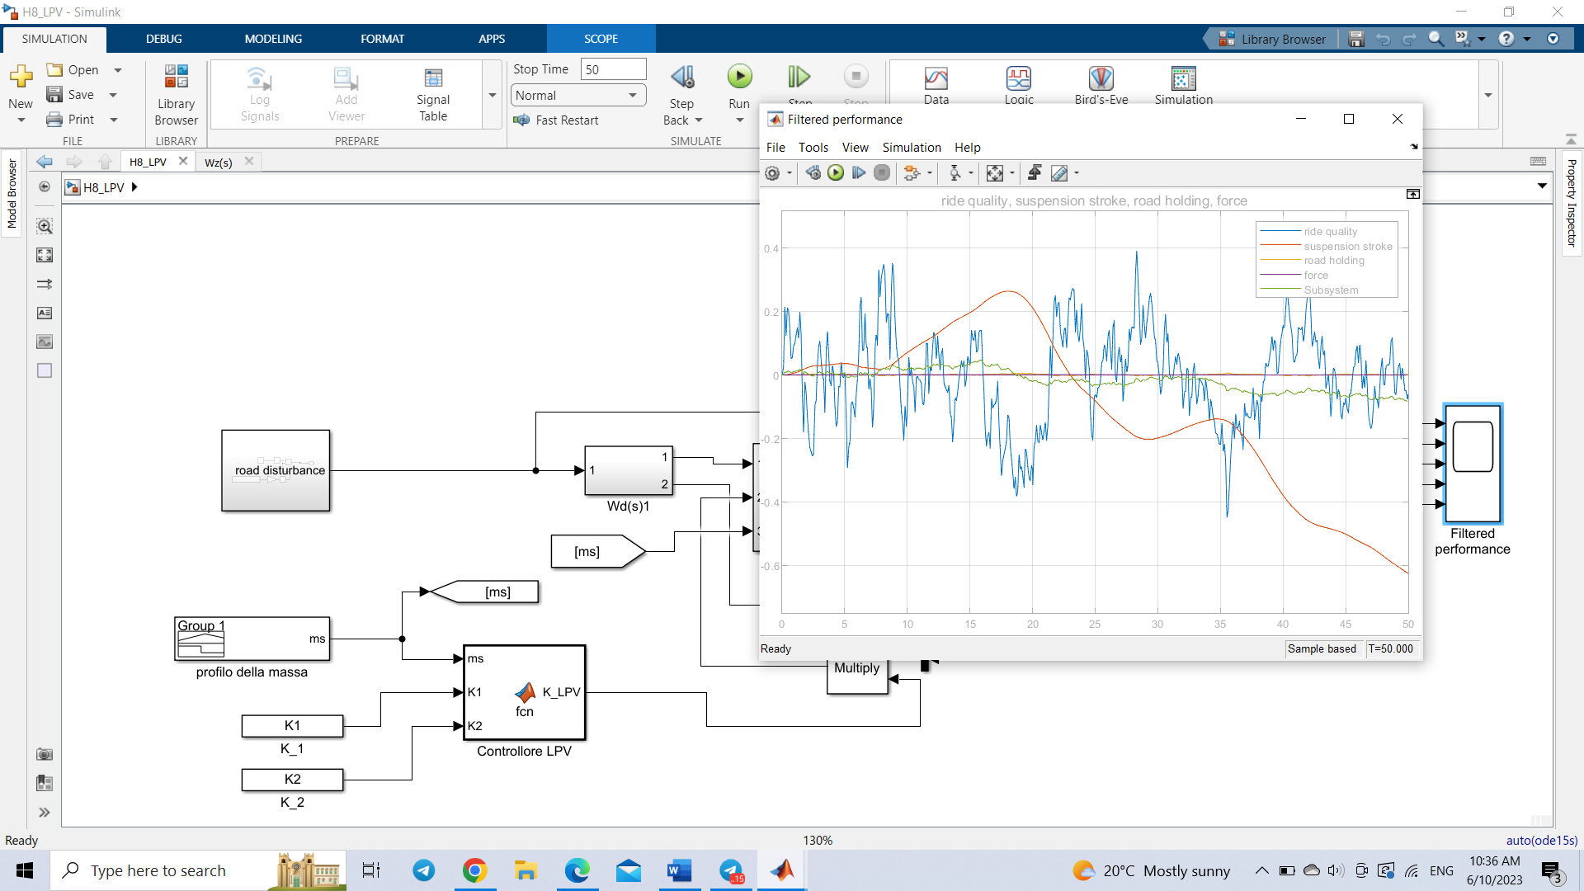

Fig.4.6.3. Filtered output of $H_{∞}$ optimal LPV controller

It is possible to observe that $H_{∞}$ optimal LPV controller achieves a better result compared to $H_{∞}$ robust controller due to possibility to measure parameters online.

* 1. **State flow controller**

State-flow is a toolbox in Matlab that facilitates the modeling and simulation of state machines and flowcharts. It offers the capability to model intricate systems, which include:

* Simulating complex logic
* Simulating hierarchical and parallel systems with time and event operators
* Representing state machines through state diagrams, state transition tables and transition matrices
* Utilizing flow diagrams and truth tables.

The State-flow environment also supports analysis and debugging phases through activity animation techniques and integrity control systems. Additionally, for the simulation phase, State-flow requires a C compiler. The State-flow schema is compiled to generate a dynamic library for simulation purposes.

**Condition**

Condition is a Boolean operation that determines whether the transition can be made or not. Conditions can be:

• Boolean expressions

• Functions that return true or false

• The operation in (state name) that defines whether the defined state is active

• Temporal conditions

**Condition action**

These are operations put between two curly brackets {} and are executed if the condition is true, before the transition destination is reached (state or junction). Unlike transition action the operation is executed even if a new state cannot be reached later.

**Transition action**

These actions are preceded by a / sign and can be executed only if it is possible to reach the end of the transition, otherwise they are ignored. This means, for example, that if this action leads to a join, it must be possible to continue and \ reach the end state.

**Data**

Data objects are used to store numerical values in the State flow diagram. They are non-graphical objects and are not represented directly in a State flow chart. It is possible to create and modify data objects in State flow Explorer. Data objects have a property called “scope” that defines whether the data object is:

• Local to the State-flow diagram

• An input to the State flow diagram from its Simulink model

• An output from the State flow diagram to its Simulink model

• Defined in the Matlab workspace

In this project state flow control was combined with $H_{∞}$ robust controller. Particularly, uncertain parameter $200≤m_{s}\left(t\right)≤400$ is divided into 4 intervals:

$$200≤m_{s}\left(t\right)≤250$$

$$250≤m_{s}\left(t\right)≤300$$

$$300≤m_{s}\left(t\right)≤350$$

$$350≤m_{s}\left(t\right)≤400$$

Then, corresponding $H_{∞}$ robust controllers $K_{1}, K_{2}, K_{3}, K_{4}$

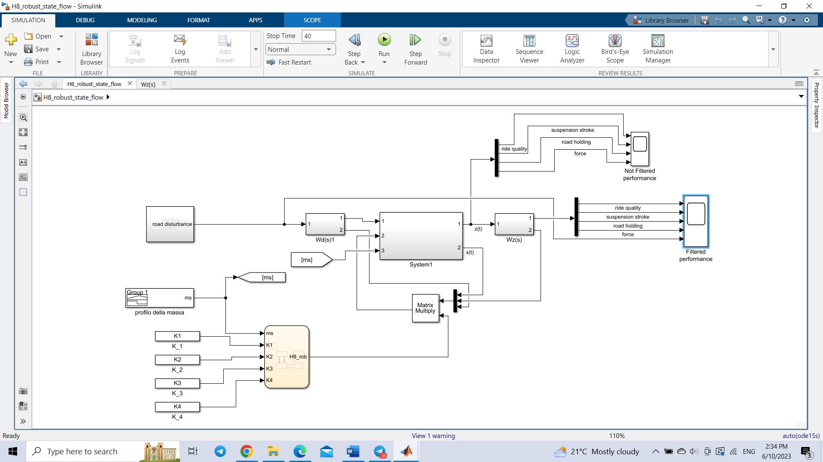

Fig.4.7.2. Overall control architechture in Simulink

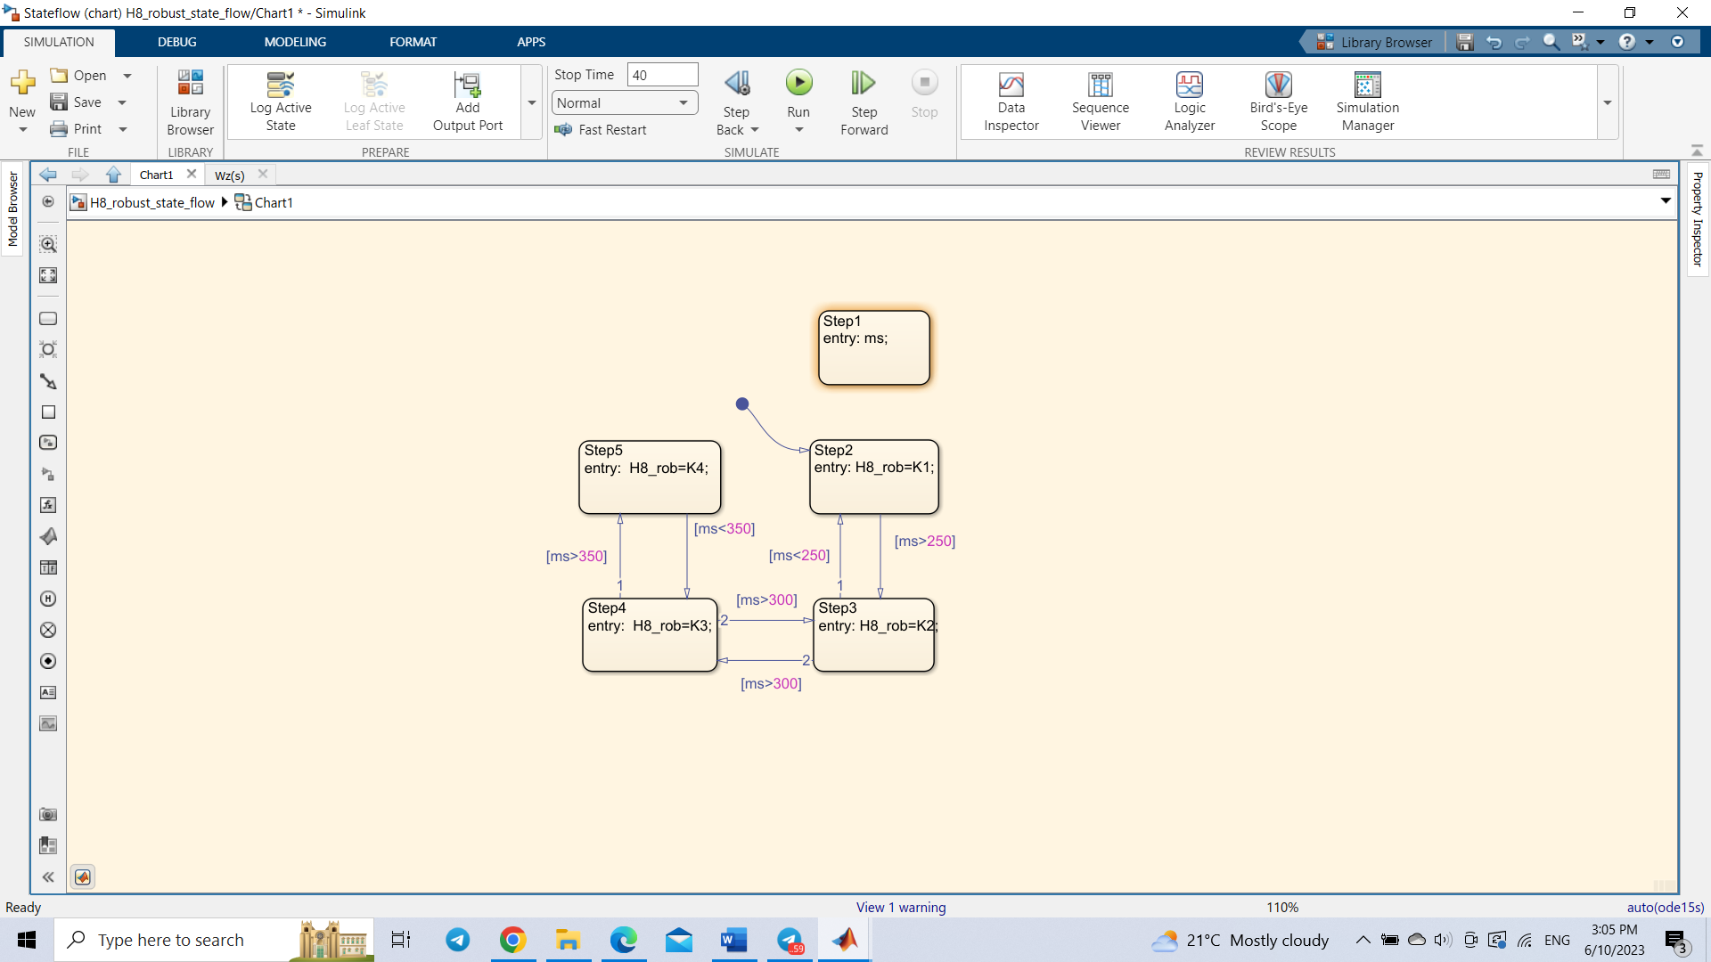

Fig.4.7.3. State-flow control for active suspension system

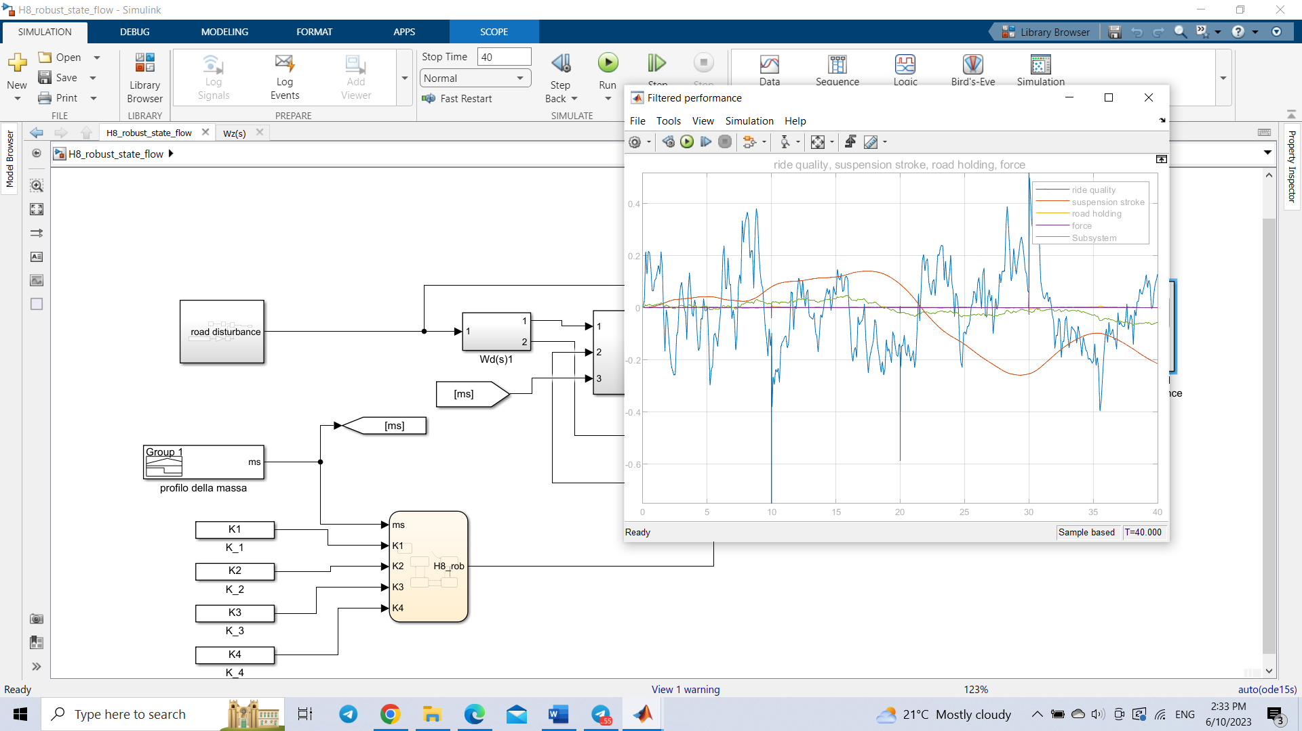

Fig.4.7.4. Filtered output of $H_{∞}$ robust controller

1. **Conclusion**

In conclusion, this project aimed to design and implement various controllers for an active suspension system, all of which successfully met the classical requirements of the system. The controllers considered in this project included optimal $H_{∞}$, optimal $H_{2}$, multiobjective control, robust $H_{∞}$, optimal $H_{∞}$ LPV, and state-flow controllers.

Among these controllers, the $H_{2}$ controller demonstrated the best overall performance. Its design led to significant improvements in system stability and enhanced ride comfort. Additionally, the incorporation of alpha stability techniques further enhanced the performance of the H infinity controller, contributing to better system response and robustness.

Furthermore, the project addressed the challenge of parameter uncertainty, particularly focusing on the uncertain spring mass. In such scenarios, the robust controller played a crucial role in stabilizing the system, ensuring reliable operation even in the presence of parameter variations and uncertainties. Moreover, the $H_{∞}$ LPV controller showed promising results by further improving the performance of the robust controller. By considering the varying parameters within the system, the LPV controller effectively adapted the control strategy, enhancing system stability and robustness.

Additionally, the state-flow controller proved to be beneficial when considering uncertainties in intervals. By modeling and analyzing the system's behavior within specified intervals, the state-flow controller offered a practical solution to handle uncertainty, allowing for more accurate and reliable control.

Overall, this project's findings highlight the successful implementation of various controllers to meet the classical requirements of an active suspension system. The superior performance of the $H_{2}$ controller, the improved performance achieved through alpha stability and LPV techniques, the effectiveness of the robust controller in handling parameter uncertainties, and the contribution of the state-flow controller in managing interval uncertainties all demonstrate significant advancements in the field of active suspension systems. These outcomes contribute to the development of more robust, adaptive, and efficient active suspension systems, resulting in improved ride quality and vehicle handling.

1. **Reference**s
2. A. Cassavola, (2022-2023). Class Notes.
3. G. Gianfranco, (2022-2023) Presentations
4. ISO 2631-1:1997, "Mechanical vibration and shock Evaluation of human exposure to whole body vibration", Geneva (Switzerland): International Organization for Standardization, 1997.
5. A. Cassavola, Fabio di Iorio, “Lezione Sospensioni”
6. S. Spagnuolo, Tesi di laurea sperimentale, “Controllo di ammortizzatori rigenerativi in retroazione dinamica dall’uscita: confronti tra azionamenti lineari e rotativi”
7. Yunqing Zhang, Wei Chen Liping Chen1, Wenbin Shangguan, Non-stationary Random Vibration Analysis of Vehicle with Fractional Damping